|  |  |  |  |  |
| --- | --- | --- | --- | --- |
|  |  | | |  |
|  |  | | |  |
|  | Buttonless Start  <<Feature>>  (F000604) | | |  |
|  |  | | |  |
| Document Type | **Feature Document (FD)** | | |  |
| Template Version | **6.1b** | | |  |
| SysML Report Template Version | **O Beta (4/19/2021)** | | |  |
| Document ID | **ffst01.10_featuredocument_sysmlreporttemplate** | | |  |
| Document Location |  | | |  |
| Document Owner | **Wander Cristiano (WCRISTIA)**  **Fernando Sarracini (FSARRACI)** | | |  |
| Document Revision | **FD0** | | |  |
| Document Status | **Rev01** | | |  |
| Date Issued | **2021/04/29** | | |  |
| Date Revised | **2021/04/29** | | |  |
| Document Classification | GIS1 Item Number: | **27.60/35** | |  |
| GIS2 Classification: | **Confidential** | |
|  | | | | |
|  | | | | |
| Document Approval | | | | |
| Person | Role | | Email Confirmation | Date |
|  |  | |  |  |
|  |  | |  |  |

**Auto-Generated by MagicDraw**

Printed Copies Are Uncontrolled

# Disclaimer

**This document contains Ford Motor Company Confidential information. Disclosure of the information contained in any portion of this document is not permitted without the expressed, written consent of a duly authorized representative of Ford Motor Company, Dearborn, Michigan, U.S.A.**

**Copyright, Ó 2021 Ford Motor Company**

This document contains information developed and accumulated by and for FORD MOTOR COMPANY. As such, it is a proprietary document, which, if disseminated to unauthorized persons, would provide others with restricted information, data, or procedures not otherwise available, exposing the FORD MOTOR COMPANY to potential harm.

Employees and suppliers having custody of this specification or authorized to use it must be cognizant of its proprietary nature and ensure that the information herein is not made available to unauthorized persons.

FORD MOTOR COMPANY reserves the right to protect this work as an unpublished copyrighted work in the event of an inadvertent or deliberate unauthorized publication. FORD MOTOR COMPANY also reserves its rights under copyright laws to protect this work as a published work.

This document or portions thereof shall not be distributed outside FORD MOTOR COMPANY without prior written consent. Refer all questions concerning disclosure to the author(s) or to any duly authorized representative of Ford Motor Company.

# Contents

Disclaimer 2

Contents 3

1 Introduction 5

1.1 Document Purpose 5

1.2 Document Scope 5

1.3 Document Audience 5

1.3.1 Stakeholder List 5

1.4 Document Organization 5

1.4.1 Document Context 5

1.4.2 Document Structure 6

1.5 Document Conventions 6

1.5.1 Classification of Chapters 6

1.5.2 Requirements Templates 6

1.6 References 7

1.6.1 Ford Documents 7

1.6.2 External Documents and Publications 7

1.7 Glossary 7

1.7.1 Definitions 7

1.7.2 Abbreviations 7

1.7.3 Parameters / Values 7

2 Feature Overview 8

2.1 Purpose and Description of Feature 8

2.2 Feature Variants 9

2.2.1 Regions & Markets 9

2.3 Input Requirements/Documents 9

2.3.1 Legal Requirements 9

2.3.2 Trustmark Requirements 9

2.3.3 Industry Standards 9

2.4 Lessons Learned 9

2.5 Assumptions 9

3 Feature Context 10

3.1 Feature Context Diagram 10

3.2 List of Influences 10

4 Feature Modeling 12

4.1 Operation Modes and States 12

4.2 Use Cases 15

4.2.1 Use Case Diagram 15

4.2.2 Actors 16

4.2.3 Use Case Descriptions 17

4.3 Driving and Operation Scenarios 20

4.4 Decision Tables 25

5 Feature Requirements 26

5.1 Functional Requirements 26

5.1.1 Error Handling 32

5.2 Non-Functional Requirements 32

5.2.1 Safety 32

5.2.2 Security 32

5.2.3 Reliability 33

5.2.4 Performance 33

5.3 HMI Requirements 33

5.4 Other Requirements 36

5.4.1 Design Requirements 36

5.4.2 Manufacturing Requirements 36

5.4.3 Service Requirements 36

5.4.4 After Sales Requirements 36

5.4.5 Process Requirements 36

6 Functional Safety 38

6.1 System Behaviors for HARA 38

6.2 Functional Safety Assumptions 39

6.3 Safety Goals 39

6.4 Functional Safety Requirements 39

6.4.1 Safety Goal: PUPD1 SG1 40

6.4.2 Safety Goal: SG-000452/A Prevent Fire Caused by Overheating of Cranking Device 40

6.4.3 Safety Goal: SG-000453/A Prevent Accumulation of Tailpipe Emissions 41

6.4.4 Safety Goal: SG-001288/A Prevent Unintended Launch 42

6.4.5 Derivation of Functional Safety Requirements on Assumptions 42

6.4.6 ASIL Decomposition of Functional Safety Requirements 42

7 CyberSecurity 43

7.1 Security Goals 43

7.2 Cybersecurity Requirements 43

8 Architecture 44

8.1 Functional Decomposition 44

8.1.1 Functions 45

8.2 Logical Architecture 46

8.2.1 Logical Elements 46

8.2.2 Logical Interfaces 47

9 Traceability Matrix 49

10 Open Concerns 50

11 Revision History 51

12 Appendix 52

12.1 Definitions 52

12.2 Abbreviations 52

**List of Figures**

Figure 2: ButtonLess Start 9

Figure 4: Feature Context 10

Figure 5: Buttonless State Machine 12

Figure 6: Buttonless Use Cases 16

Figure 7: W&RC #1 Diagram – Prevent Fire Caused by Overheating of Cranking Device 41

Figure 8: Functional Architecture 44

Figure 9: Logical Architecture 46

**List of Tables**

Table 1: Features described in this FD 5

Table 4: Ford internal Documents 7

Table 6: External documents and publications 7

Table 8: Parameters / Values used in this document 7

Table 2: Feature Variants 9

Table 3: Regions & Markets 9

Table 9: List of Influences 11

Table 10: Operation Modes and States on Buttonless State Machine 13

Table 11: Transitions between Operation Modes and States on Buttonless State Machine 15

Table 12: List of Actors 17

Table 13: System Behaviors for HARA 39

Table 15: Functional Safety Goals 39

Table 18: Cybersecurity Goals 43

Table 16: List of Functions 46

Table 19: Logical Elements 47

Table 18: Feature Interactions 48

Table 20: Open Concerns *(Not supported by MagicDraw report generation)* 50

Table 21: Definitions used in this document 52

Table 22: Abbreviations used in this document 53

Introduction

## Document Purpose

A Feature Document (FD) document defines a Feature on [Concept Level](https://bd101001.pd2.ford.com/stages/#/workspace/209/_vv/(process/activity/_Y6ftAPI2VsW5zd82DgHb6g)). It specifies **what** the feature shall do and how it shall behave from customer perspective. It should also provide reasoning and background **why** we have the feature in the vehicle.

The FD also serves as an Item Definition as defined by ISO26262 for those features, which follow the Ford Functional Safety process. Refer [FFSG01.10 Feature Document Guideline](https://azureford.sharepoint.com/sites/GlobalFunctionalSafety/Released%20Templates%20Guidelines%20and%20Examples/Guidelines/FFSG01.10_FeatureDocument_Guideline.pdf) for how to apply the Feature Doc template for Functional Safety.

## Document Scope

This Feature Document (FD) specifies the following features:

|  |  |  |  |
| --- | --- | --- | --- |
| **Feature ID** | **Feature Name** | **Owner** | **Reference** |
| F000604 | Buttonless Start  (Program(s): CDX74X 24MY) | Wander Cristiano (WCRISTIA)  Fernando Sarracini (FSARRACI) |  |

Table 1: Features described in this FD

## Document Audience

The FD is written by the feature owner of Wander Cristiano (WCRISTIA)

Fernando Sarracini (FSARRACI)

. All Stakeholders, i.e., all people who have a valid interest in the feature should read and, if possible, review the FD. It needs to be guaranteed, that all stakeholders have access to the currently valid version of the FD.

### Stakeholder List

For the latest list of stakeholder of the feature and their influence refer to <Put VSEM Link here>.

|  |  |  |  |  |
| --- | --- | --- | --- | --- |
| **Name** | **CDSID** | **Contact Info** | **Role** | **Stakeholder Group** |
| Carlos Airon | CPINTO23 |  | MBSE Engineer | Systems Engineer |
| David Treharne | DTREHARN |  | EPE TS | EPE |
| Elvia Trujillo | ETRUJIL1 |  | Functional Safety Supervisor | FuSa |
| Wander Cristiano | WCRISTIA |  | Feature Owner | Systems Engineer |
| Sally Cherian | SCHERIA2 |  | Remote Start Feature Owner | Systems Engineer |
| Reace Head | RHEAD17 |  | Feature Owner | EPE |
| Paul Braithwaite | PBRAITH1 |  | Starting Feature Supervisor | Systems Engineer |
| Fernando Sarracini | FSARRACI |  | Feature Owner Supervisor | Systems Engineer |
| Davud Kucukarslan | DUCUKAR |  | Functional Safety Engineer | FuSa |

## Document Organization

### Document Context

Refer to the [Specification Structure page](http://wiki.ford.com/display/RequirementsEngineering/Specification+templates) in the [Ford RE Wiki](http://wiki.ford.com/display/RequirementsEngineering/Requirements+Engineering+for+SW+Enabled+Features) to understand how the FD relates to other Ford Requirements Documents and Specifications.

### Document Structure

The structure of this document is explained below:

**Introduction** – Explains how to use this document including responsibilities and requisite documents. Explains the terminology. Gives a clarification of the definitions, concepts and abbreviations used in the document.

**Feature Overview** – States briefly the background and the purpose of the feature, feature variants and corresponding regions and markets. Also includes input requirements, assumptions and constraints.

**Feature Context** – describes all external entities, which have an influence on the feature.

**Feature Modeling** – Contains Use Case, Driving Scenarios, State Charts to describe the functional behavior of the feature.

**Feature Requirements** – Lists functional and non-functional requirements of the feature.

**Functional Safety** – Lists System Behaviors, Safety Goals and Safety Requirements of the feature.

**Cybersecurity** – Lists Security Goals and Security Requirements of the feature.

**Architecture** – Shows the coarse architecture, which the feature requirements are deployed to. Describes the elements and the boundary of the feature as well as the decomposition and distribution of associated functions.

**Traceability Matrix** – Traceability Matrix.

**Open Concerns** – List of Open Concerns

**Revision History** – Document Change History including a list of new or modified requirements. The requirements in this document are tagged, and this section contains different types of tables listing all, new, or changed requirements by their title and page no.

**Appendix** – Appendix

## Document Conventions

### Classification of Chapters

A chapter is considered mandatory, unless the chapter or its parent chapter(s) are categorized by using the tag:

**#Classification:** Some Condition

If no requirement/other content is known for a mandatory chapter, leave a statement “Not Applicable”

Some chapters have a follow certain rules in context of specific Ford processes, e.g. Functional Safety. This is indicated at the beginning of the corresponding chapter by the tags:

**#Functional Safety:** Some process specific explanation

**#Cybersecurity:** Some process specific explanation

### Requirements Templates

Refer to “[How to use the Specification Templates](http://wiki.ford.com/display/RequirementsEngineering/How+to+use+the+Specification+Templates?src=contextnavpagetreemode)” on how to use the specification templates and the VBA macros to create/edit the requirements in the specifications.

#### **Requirements Attributes**

The templates provided by *Specification_Macros.dotm* define a list of attributes for each requirement. This helps to classify the requirement. The attributes are explained at [RE Wiki - Requirements Attributes](http://wiki.ford.com/display/RequirementsEngineering/Requirements+Attributes?src=contextnavpagetreemode).

## References

### Ford Documents

List here all Ford internal documents, which are directly related to the feature.

| **Reference** | **Title** | **Doc. ID** | **Document Location** | **Revision** |
| --- | --- | --- | --- | --- |
| VSEM | HLFR_PUPD (042210) Rev D | 042210 | https://www.vsemawc.ford.com/awc/#/com.siemens.splm.clientfx.tcui.xrt.showObject?uid=ixch05XDx3NrTD | D |
| VSEM F000400 | F000400 - Remote Start |  |  |  |
| VSEM F002930 | F002930 - RePA (Remote Park Assist) |  |  |  |

Table 4: Ford internal Documents

### External Documents and Publications

The list of external documents could include books, reports and online sources.

| **Reference** | **Document / Publication** | **Document Location** |
| --- | --- | --- |
| International Standard ISO 26262 | International Standard ISO 26262 – Road Vehicles |  |

Table 6: External documents and publications

## Glossary

**See Appendix for Definitions and Abbreviations.**

### Definitions

### Abbreviations

### Parameters / Values

| **Name** | **Description** | **Range / Resolution** |
| --- | --- | --- |

Table 8: Parameters / Values used in this document

# Feature Overview

## Purpose and Description of Feature

The Buttonless Start feature allows better user experience by starting the vehicle and allowing the vehicle to drive away without a need for Start Stop button or rotary key system. This feature is part of Drive Control Optimization (DCO) which intends to reduce the vehicles operational reliance on single-purpose interfaces, such as push-to-start and electronic park brake switches.

General feature description:

When user enters the vehicle, it turns “on” (ISPR ON / HV Closed) automatically when the driver’s door is closed and an authorized “key” is detected in the passenger compartment. When in HV Closed mode, all vehicle functionality, with the exception of vehicle propulsion, is available to the user. Vehicle propulsion becomes available to the user once they place their foot on the brake and select a desired drive range (i.e. Drive or Reverse). In the event that the driver’s door does not transition to closed (or any other situation where the ISPR is not ON), a brake pedal apply will also transition the vehicle into a HV Closed mode, as long as a valid “key” is detected in the passenger compartment.

Powering up the vehicle achieves a transition into the following two states when user intends to start the vehicle:

- HV Closed mode;

- Motive mode ON (propulsive torque available): powertrain can provide torque to the wheels to accelerate or decelerate the vehicle.

The Buttonless start feature improves user experience by automatically powering down the vehicle when the driver intends to shutdown the vehicle. This is usually achieved by driver exiting the vehicle with the door transition to close and no valid key detected in the passenger compartment. Powering down the vehicle achieves a transition from a torque available mode to a vehicle off mode~~.~~ (ISPR OFF) when user intends to shutdown the vehichle.

**2.1.1 Buttonless Start Feature HMI**

Buttonless Start Feature HMI can be divided into 2 groups:

1) User Control Pedals and Shifter Positions – Actions handled by driver/user (i.e: Press brake pedal and shift out of park to enter Motive mode ON).

2) Auto-Generated Feedback – Actions handled by ECU’s (i.e: Cluster displaying “To Drive: Press Brake and Gear Shift Button”).

**2.1.1.1 Pedals (Automatic Transmission) and Shifter HMI**

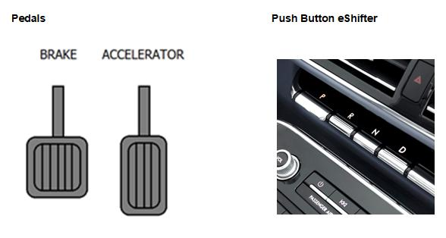

Figure 2: ButtonLess Start

## Feature Variants

|  |  |  |
| --- | --- | --- |
| **Variant Name** | **Variant Description** | **Remarks** |
| **BEV** | BEV - Battery Electric Vehicle |  |

Table 2: Feature Variants

### Regions & Markets

|  |  |  |  |  |  |  |
| --- | --- | --- | --- | --- | --- | --- |
| **Market /**  **Region**  Variant Name | **North America** | **South America** | **Europe** | **Middle East/Africa** | **Asia / Pacific** | **China** |
| **BEV** | Mandatory | No | Mandatory | No | No | Mandatory |

Table 3: Regions & Markets

## Input Requirements/Documents

### Legal Requirements

* : FMVSS305
  + The Feature shall comply with FMVSS305.
  + Isolation requirements for AC and DC high voltage sources.
  + Mitigating driver error
* : FMVSS102
  + The Feature shall comply with FMVSS102.

Engine Braking through Trans \/ FMVSS102 (shift mode, button, steering wheel paddle, etc.).

### Trustmark Requirements

No Trustmark Requirements specified.

### Industry Standards

* : ISO 26262
  + The system should be developed according to Ford's implementation of Functional Safety.

## Lessons Learned

No lessons learned specified.

## Assumptions

This document assumes a BEV vehicle with push buttons eShifter. The functional requirements for a non-BEV vehicle are not covered in this feature document.

# Feature Context

## Feature Context Diagram

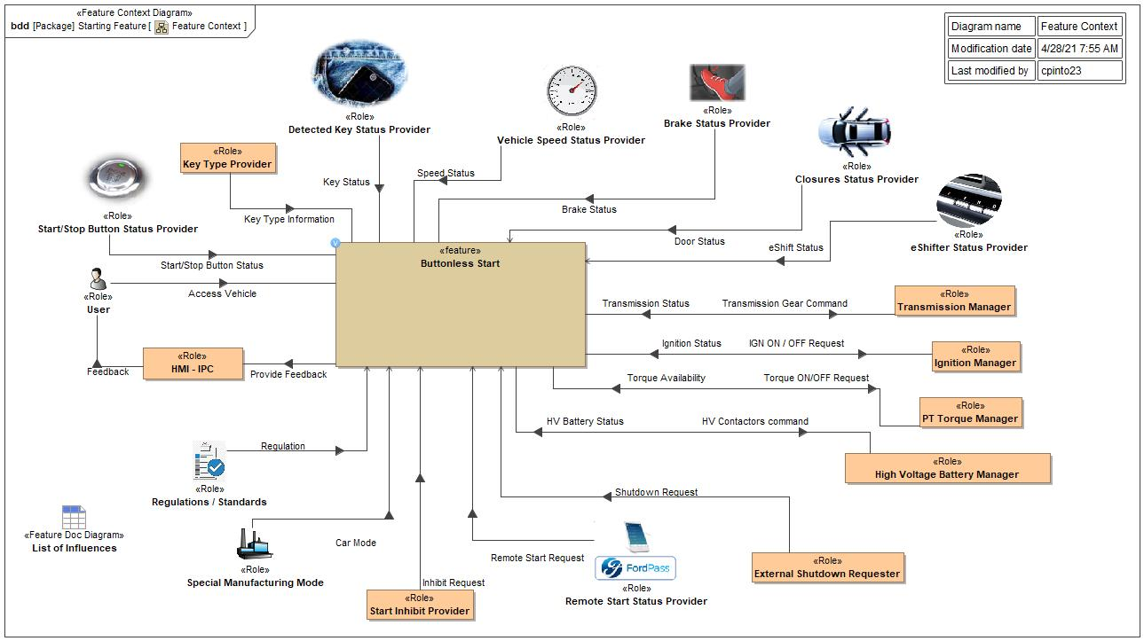

Figure 4: Feature Context

## List of Influences

|  |  |  |
| --- | --- | --- |
| **ID** | **External Entity** | **Influence Description** |
| Access Vehicle | User To Buttonless Start | User entering the vehicle |
| Brake Status | Brake Status Provider To Buttonless Start | Brake press information |
| Car Mode | Special Manufacturing Mode To Buttonless Start | Car modes: normal, transport, factory |
| Door Status | Closures Status Provider To Buttonless Start | Door switch information |
| eShift Status | eShifter Status Provider To Buttonless Start | Shifter position information |
| Feedback | HMI - IPC To User | HMI messages, instructions, indications |
| HV Battery Status | High Voltage Battery Manager To Buttonless Start | HV contactors status |
| HV Contactors command | Buttonless Start To High Voltage Battery Manager | HV contactors status |
| IGN ON / OFF Request | Buttonless Start To Ignition Manager | Ignition request: IGN ON = ISPR ON, IGN OFF = ISPR OFF |
| Ignition Status | Ignition Manager To Buttonless Start | Ignition status on CAN |
| Inhibit Request | Start Inhibit Provider To Buttonless Start | Inhibit request like Immobilizer, OTA etc |
| Key Status | Detected Key Status Provider To Buttonless Start | Key status: detected or not detected inside the vehicle |
| Key Type Information | Key Type Provider To Buttonless Start | Key type: NFC, PaaK |
| Provide Feedback | Buttonless Start To HMI - IPC | Messages and indications request to HMI. |
| Regulation | Regulations / Standards To Buttonless Start | Legal requirements (if applied) |
| Remote Start Request | Remote Start Status Provider To Buttonless Start | Remote Start request. |
| Shutdown Request | External Shutdown Requester To Buttonless Start | External shutdown request like AEIS/DSIS. |
| Speed Status | Vehicle Speed Status Provider To Buttonless Start | Vehicle speed information |
| Start/Stop Button Status | Start/Stop Button Status Provider To Buttonless Start | Start/Stop button information if pressed or not. |
| Torque Availability | PT Torque Manager To Buttonless Start | Torque availability status. Torque ON / OFF (Available / Not Available) |
| Torque ON/OFF Request | Buttonless Start To PT Torque Manager | Torque request. |
| Transmission Gear Command | Buttonless Start To Transmission Manager | Engage gear. |
| Transmission Status | Transmission Manager To Buttonless Start | Transmission gear position status. |

Table 9: List of Influences

# Feature Modeling

## Operation Modes and States

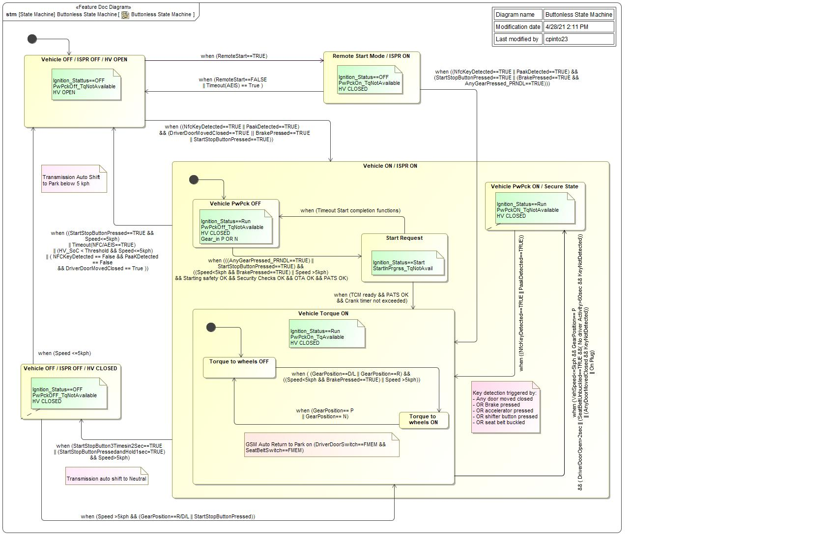

Figure 5: Buttonless State Machine

|  |  |  |
| --- | --- | --- |
| **State** | **Description** | **Requirements Reference** (optional) |
| Remote Start Mode / ISPR ON | Ignition_Stattus==OFF  PwPckOn_TqNotAvailable  HV CLOSED |  |
| Start Request | Ignition_Status==Start  StartInPrgrss_TqNotAvail |  |
| Torque to wheels OFF | Ignition Status = RUN  ISPR ON, HV Closed  PwPckOn_TqAvailable  Gear in P or N |  |
| Torque to wheels ON | Ignition Status = RUN  ISPR ON, HV Closed  PwPckOn_TqAvailable  Gear in D/L or R |  |
| Vehicle OFF / ISPR OFF / HV CLOSED | Ignition_Status==OFF  PwPckOFF_TqNotAvailable  HV CLOSED |  |
| Vehicle OFF / ISPR OFF / HV OPEN | Ignition_Stattus==OFF  PwPckOff_TqNotAvailable  HV OPEN |  |
| Vehicle ON / ISPR ON | Ignition Status = RUN  ISPR ON, HV Closed |  |
| Vehicle PwPck OFF | Ignition_Status==Run  PwPckOff_TqNotAvailable  HV CLOSED |  |
| Vehicle PwPck ON / Secure State | Ignition_Status==Run  PwPckON_TqNotAvailable  HV CLOSED |  |
| Vehicle Torque ON | Ignition_Status==Run  PwPckOn_TqAvailable  HV CLOSED |  |

Table 10: Operation Modes and States on Buttonless State Machine

|  |  |  |  |  |
| --- | --- | --- | --- | --- |
| **Transition ID** | **Source** | **Destination** | **Description** | **Requirements Reference**  (optional) |
| T1 | Vehicle OFF / ISPR OFF / HV OPEN | Vehicle ON / ISPR ON | Name: Turn Vehicle ON  Guard: =  ChangeEvent when ((NfcKeyDetected==TRUE || PaakDetected==TRUE) && (DriverDoorMovedClosed==TRUE || BrakePressed==TRUE || StartStopButtonPressed==TRUE)) |  |
| T2 | Vehicle ON / ISPR ON | Vehicle OFF / ISPR OFF / HV CLOSED | Name: Turn Vehicle OFF by press and hold Start Stop Button  ChangeEvent when (StartStopButton3Timesin2Sec==TRUE || (StartStopButtonPressedandHold1sec=TRUE) && Speed>5kph) |  |
| T3 | Vehicle PwPck OFF | Start Request | ChangeEvent when (((AnyGearPressed_PRNDL==TRUE) || StartStopButtonPressed==TRUE) && ((Speed<5kph && BrakePressed==TRUE) || Speed >5kph) && Starting safety OK && Security Checks OK && OTA OK && PATS OK) |  |
| T4 | Remote Start Mode / ISPR ON | Vehicle OFF / ISPR OFF / HV OPEN | Name: Remot Start OFF  ChangeEvent when (RemoteStart==FALSE || Timeout(AEIS) == True ) |  |
| T5 | Torque to wheels OFF | Torque to wheels ON | ChangeEvent when ( (GearPosition==D/L || GearPosition==R) && ((Speed<5kph && BrakePressed==TRUE) || Speed >5kph)) |  |
| T6 | Remote Start Mode / ISPR ON | Vehicle Torque ON | ChangeEvent when ((NfcKeyDetected==TRUE || PaakDetected==TRUE) && (StartStopButtonPressed==TRUE || (BrakePressed==TRUE && AnyGearPressed_PRNDL==TRUE))) |  |
| T7 | Torque to wheels ON | Torque to wheels OFF | Name: Applying torque to wheel  ChangeEvent when (GearPosition== P || GearPosition== N) |  |
| T8 |  |  | Name: Vehicle ON start state |  |
| T9 | Vehicle OFF / ISPR OFF / HV OPEN | Remote Start Mode / ISPR ON | Name: Remote Start ON  ChangeEvent when (RemoteStart==TRUE) |  |
| T10 | Start Request | Vehicle Torque ON | ChangeEvent when (TCM ready && PATS OK && Crank timer not exceeded) |  |
| T11 |  |  | Name: Vehicle Torque ON start state |  |
| T12 | Vehicle Torque ON | Vehicle PwPck ON / Secure State | ChangeEvent when (VehSpeed<=5kph && GearPosition== P && ( DriverDoorOpen>2sec || (SeatBeltUnbuckled==TRUE &&( No driver Activity>60sec && KeyNotDetected)) || (AnyDoorMovedClosed && KeyNotDetected)) || On Plug) |  |
| T13 | Vehicle ON / ISPR ON | Vehicle OFF / ISPR OFF / HV OPEN | Name: Turn Vehicle OFF  ChangeEvent when ((StartStopButtonPressed==TRUE && Speed<=5kph) || Timeout(NFC/AEIS==TRUE) || (HV_SoC < Threshold && Speed<=5kph) || ( NFCKeyDetected == False && PaaKDetected == False && DriverDoorMovedClosed == True )) |  |
| T14 | Start Request | Vehicle PwPck OFF | ChangeEvent when (Timeout Start completion functions) |  |
| T15 | Vehicle OFF / ISPR OFF / HV CLOSED | Vehicle OFF / ISPR OFF / HV OPEN | Name: Turn Vehicle OFF when speed is <= 5kph  ChangeEvent when (Speed <=5kph) |  |
| T16 | Vehicle PwPck ON / Secure State | Vehicle Torque ON | ChangeEvent when ((NfcKeyDetected==TRUE || PaakDetected==TRUE)) |  |
| T17 |  |  | Name: Inicial start state |  |
| T18 | Vehicle OFF / ISPR OFF / HV CLOSED | Vehicle Torque ON | Name: Restore torque by eshifter  ChangeEvent when (Speed >5kph && (GearPosition==R/D/L || StartStopButtonPressed)) |  |

Table 11: Transitions between Operation Modes and States on Buttonless State Machine

## Use Cases

### Use Case Diagram

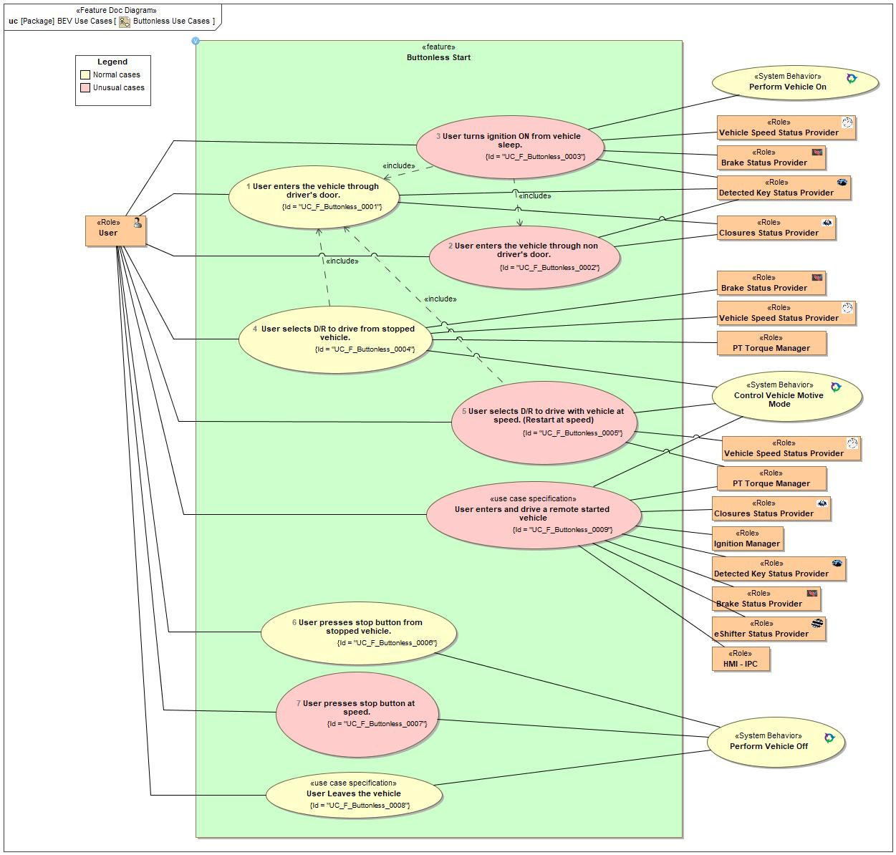

Figure 6: Buttonless Use Cases

### Actors

| **Actor** | **Description** |
| --- | --- |
| Brake Status Provider | Brake press information |
| Closures Status Provider | Door switch status |
| Detected Key Status Provider | Key detected or not detected inside the vehicle |
| eShifter Status Provider | Gear shift position status |
| HMI - IPC | Message center (IPC) |
| Ignition Manager | Ignition status (RUN, Start, OFF) and command. |
| PT Torque Manager | Modules (hardware / software) responsible to make propulsive torque available (motive mode ON) |
| User | Driver |
| Vehicle Speed Status Provider | Vehicle Speed information |

Table 12: List of Actors

### Use Case Descriptions

UC_F_Buttonless_0001 User enters the vehicle through driver's door.

|  |  |  |
| --- | --- | --- |
| **Actors** | Primary | User |
| Secondary |  |
| **Subject** |  | Buttonless Start |
| **Description** |  | User enters the vehicle through driver's door and vehicle turns ON. |
| **Preconditions** | PreC1 | Vehicle OFF |
| **Main Flow Description** |  | User enters the vehicle and HMIs are turned ON |
| **Main Flow** | M1 | User Approaches the vehicle with a valid key |
| M2 | User opens the driver's door |
| M3 | User enters the vehicle |
| M4 | User closes the driver's door |
| M5 | Vehicle turns ON |
| M6 | User gets instructions how to drive |
| **Exceptional Flow Description** |  | User stays inside vehicle with no action for a long time and vehicle returns to OFF state |
| **Exceptional Flow Steps** | E1 | Vehicle turns OFF after timeout |
| **Postconditions** | PostC1 | Vehicle ON |

UC_F_Buttonless_0002 User enters the vehicle through non driver's door.

|  |  |  |
| --- | --- | --- |
| **Actors** | Primary | User |
| Secondary |  |
| **Subject** |  | Buttonless Start |
| **Description** |  | User enters the vehicle through non driver´s door and vehicle does not turn ON |
| **Preconditions** | PreC1 | Vehicle OFF |
| **Main Flow Description** |  | Vehicle stays in OFF state |
| **Main Flow** | M1 | User approaches the vehicle with a valid key |
| M2 | User opens non driver's door |
| M3 | User sees the welcome message |
| M4 | User enters the vehicle |
| M5 | User closes non driver's door |
| **Postconditions** | PostC1 | Vehicle OFF |

UC_F_Buttonless_0003 User turns ignition ON from vehicle sleep.

|  |  |  |
| --- | --- | --- |
| **Actors** | Primary | User |
| Secondary |  |
| **Subject** |  | Buttonless Start |
| **Description** |  | User is already inside the vehicle and decide to turn vehicle on |
| **Preconditions** | PreC1 | Transmission in P |
| PreC2 | User inside the vehicle |
| PreC3 | Vehicle OFF |
| **Main Flow Description** |  | Vehicle turned on when driver press brake |
| **Main Flow** | M1 | User presses brake pedal |
| M2 | Key detected |
| M3 | Vehicle turned ON |
| M4 | User gets instructions how to drive. |
| **Postconditions** | PostC1 | Vehicle ON |

UC_F_Buttonless_0004 User selects D/R to drive from stopped vehicle.

|  |  |  |
| --- | --- | --- |
| **Actors** | Primary | User |
| Secondary | Brake Status Provider |
| Secondary | Vehicle Speed Status Provider |
| Secondary | PT Torque Manager |
| **Subject** |  | Buttonless Start |
| **Description** |  | User selects D/R to drive from stopped vehicle. |
| **Preconditions** | PreC1 | HV CLOSED / IGN ON |
| PreC2 | User inside the vehicle |
| PreC3 | Vehicle speed < 5kph |
| **Main Flow Description** |  | User inside the vehicle intends to drive |
| **Main Flow** | M1 | User presses brake pedal |
| M2 | User gets instruction to drive |
| M3 | User selects D or R in the shifter |
| **Exceptional Flow Steps** | E1 |  |
| **Postconditions** | PostC1 | Torque Available |
| PostC2 | Vehicle ON |

UC_F_Buttonless_0005 User selects D/R to drive with vehicle at speed. (Restart at speed)

|  |  |  |
| --- | --- | --- |
| **Actors** | Primary | User |
| Secondary |  |
| **Subject** |  | Buttonless Start |
| **Description** |  | User restarts the vehicle at speed |
| **Preconditions** | PreC1 | Driver inside the vehicle |
| PreC2 | Vehicle Ignition OFF, Torque Not Available, HV Closed |
| PreC3 | Vehicle speed > 5kph |
| **Main Flow Description** |  | User wants to restart the vehicle |
| **Main Flow** | M1 | User selects D/R |
| **Postconditions** | PostC1 | Torque Available |
| PostC2 | Vehicle ON |

UC_F_Buttonless_0006 User presses stop button from stopped vehicle.

|  |  |  |
| --- | --- | --- |
| **Actors** | Primary | User |
| Secondary |  |
| **Subject** |  | Buttonless Start |
| **Description** |  | User presses the Start Stop button to turn vehicle off |
| **Preconditions** | PreC1 | Vehicle ON |
| PreC2 | Vehicle speed <= 5kph |
| **Main Flow Description** |  | User turns off the vehicle |
| **Main Flow** | M1 | User presses the Start Stop button |
| **Postconditions** | PostC1 | Vehicle OFF |

UC_F_Buttonless_0007 User presses stop button at speed.

|  |  |  |
| --- | --- | --- |
| **Actors** | Primary | User |
| Secondary |  |
| **Subject** |  | Buttonless Start |
| **Description** |  | User presses the stop button to turn vehicle off at speed above 5kph |
| **Preconditions** | PreC1 | Vehicle ON |
| PreC2 | Vehicle speed > 5kph |
| **Main Flow Description** |  | Vehicle turned OFF |
| **Main Flow** | M1 | User presses the Start Stop button 3 times in 2 seconds or press and hold for 1 second. |
| M2 | User gets a message to press brake and stop the vehicle or press gear button to restart and drive. |
| **Postconditions** | PostC1 | Vehicle OFF, Ignition OFF, HV Closed (over 5 kph) |

UC_F_Buttonless_0008 User Leaves the vehicle

|  |  |  |
| --- | --- | --- |
| **Actors** | Primary | User |
| Secondary |  |
| **Subject** |  | Buttonless Start |
| **Description** |  | User leaves the vehicle and takes key with him. |
| **Preconditions** | PreC1 | Vehicle ON |
| PreC2 | Vehicle speed <=5kph |
| **Main Flow Description** |  | Vehicle will powerdown depending on key detection |
| **Main Flow** | M1 | Driver leaves the vehicle with the key |
| M2 | Driver door transitions to close |
| **Alternative Flow Steps** | A1 | Driver leaves the vehicle with the key |
| A2 | Driver door does not transition to closed |
| A3 | AEIS powers down vehicle after timer expires |
| **Exceptional Flow Steps** | E1 | Driver leaves the vehicle without the key |
| E2 | either AEIS powers down vehicle after timer expires |
| E3 | either HV state of charge goes below a threshold and vehicle is switched OFF. |
| **Postconditions** | PostC1 | Vehicle OFF |

UC_F_Buttonless_0009 User enters and drives a remote started vehicle

|  |  |  |
| --- | --- | --- |
| **Actors** | Primary | User |
| Secondary |  |
| **Subject** |  | Buttonless Start |
| **Description** |  | User press brake and select D/R to drive |
| **Preconditions** | PreC1 | Remote Start Mode: HV Closed, Ignition Status OFF, PwPckOn_TqNotAvailable |
| **Main Flow Description** |  | Vehicle motive mode turned on when driver press brake and selects D do drive |
| **Main Flow** | M1 | User enters the vehicle and closes the drivers door |
| M2 | User press brake and selects D to drive |
| **Exceptional Flow Description** |  | Vehicle motive mode turned on when driver press Stop Start button |
| **Exceptional Flow Steps** | E1 | User press Stop Start Button to drive |
| **Postconditions** | PostC1 | Torque Available |
| PostC2 | Vehicle ON |

## Driving and Operation Scenarios

User selects D/R to drive from stopped vehicle.

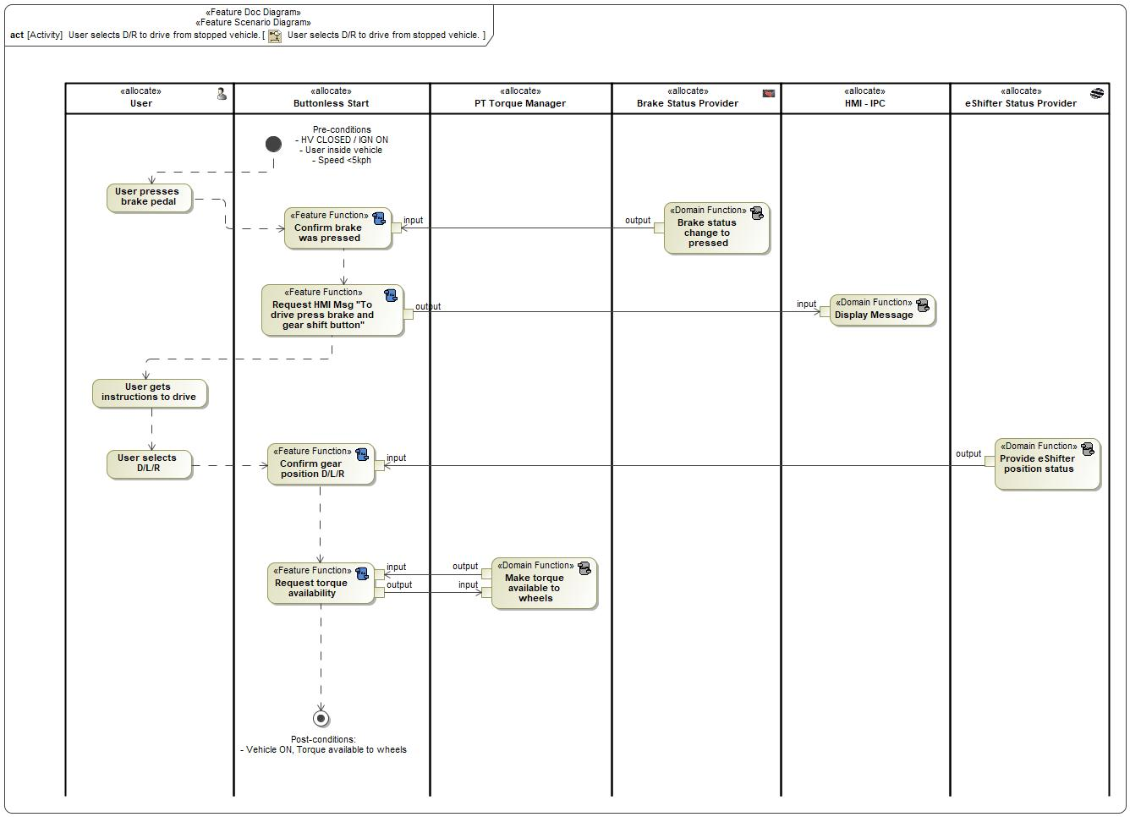

|  |  |
| --- | --- |
| **Flow of Actions** | |
| 1 | User presses brake pedal |
| 2 | Confirm brake was pressed |
| 3 | Request HMI Msg "To drive press brake and gear shift button" |
| 4 | User gets instructions to drive |
| 5 | User selects D/L/R |
| 6 | Confirm gear position D/L/R |
| 7 | Request torque availability |

User enters the vehicle through driver's door.

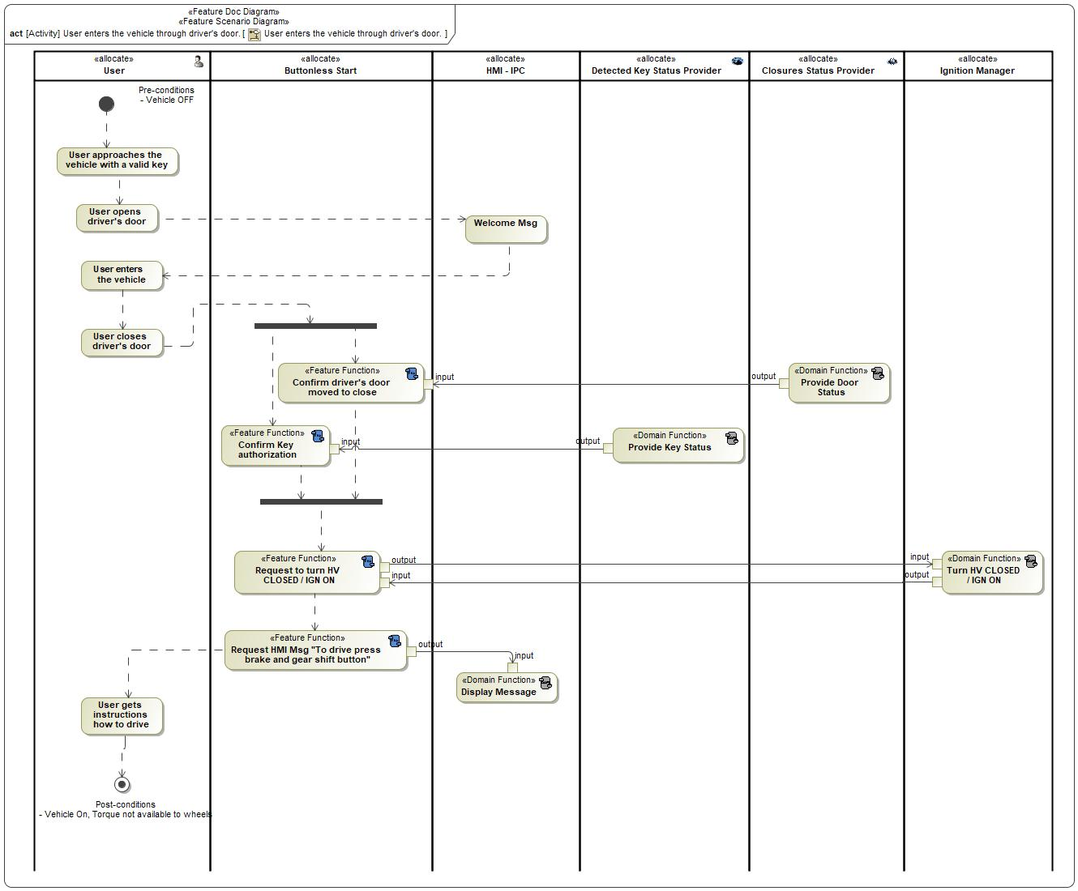

|  |  |
| --- | --- |
| **Flow of Actions** | |
| 1 | User approaches the vehicle with a valid key |
| 2 | User opens driver's door |
| 3 | Welcome Msg |
| 4 | User enters the vehicle |
| 5 | User closes driver's door |
| 6 | Confirm driver's door moved to close |
| 7 | Confirm Key authorization |
| 8 | Request to turn HV CLOSED / IGN ON |
| 9 | Request HMI Msg "To drive press brake and gear shift button" |
| 10 | User gets instructions how to drive |

## Decision Tables

**Input/Actions combinations with Stop Start Button Press and Final Conditions**





**Input/Actions combinations with Gear Button Press and Final Conditions**



# Feature Requirements

## Functional Requirements

###R_F_STRT_BTL_FD_00004### Remote Start Mode Exit

Buttonless feature:

Remote Start mode shall be exited (ignition goes from OFF to RUN) when:

- brake is pressed AND any gear button is pressed (PRNDL) AND valid key is detected inside the vehicle. This condition takes to PwPckON_TqAvailable;

- OR Stop Start Button is pressed AND valid key is detected. This condition takes to PwPckON_TqAvailable.

Note: Remote start status shall be used to maintain ignition_status = OFF on driver´s door moved closed with valid key detected if remote start is active.

|  |  |  |  |  |  |  |  |
| --- | --- | --- | --- | --- | --- | --- | --- |
| Requirement ID: | | | | | | | |
| **Rationale** |  | | | | | | |
| **Acceptance Criteria** |  | | | | | | |
| **Notes** |  | | | | | | |
| **Source** |  | | | | | **Owner** |  |
| **Source Req.** |  | | | | | **V&V Method** |  |
| **Type** |  | | | **Priority** |  | **Status** | In-Progress |
| [Req. Template](http://wiki.ford.com/display/RequirementsEngineering/Requirements+Attributes) Version | | 6.0 | End of Requirement | | | | |

###R_F_STRT_BTL_FD_00010### Start Stop Button Inadvertent request

Buttonless feature:

Stop Button Press shall avoid inadvertent button press over 5kph vehicle speed. At speed, the user needs to either press and hold for 1 second, or press the button 3 times in 2 seconds.

|  |  |  |  |  |  |  |  |
| --- | --- | --- | --- | --- | --- | --- | --- |
| Requirement ID: | | | | | | | |
| **Rationale** |  | | | | | | |
| **Acceptance Criteria** |  | | | | | | |
| **Notes** |  | | | | | | |
| **Source** |  | | | | | **Owner** |  |
| **Source Req.** |  | | | | | **V&V Method** |  |
| **Type** |  | | | **Priority** |  | **Status** | In-Progress |
| [Req. Template](http://wiki.ford.com/display/RequirementsEngineering/Requirements+Attributes) Version | | 6.0 | End of Requirement | | | | |

###R_F_STRT_BTL_FD_00017### Transmission Auto Return to Park

Buttonless feature:

On all eShift vehicles, the system is required to return to the Park position when driver egress is detected. Egress is defined as either 1) Ignition is switched to the off position, or 2) Driver´s Door and Seatbelt detect that the driver is exiting the vehicle.

|  |  |  |  |  |  |  |  |
| --- | --- | --- | --- | --- | --- | --- | --- |
| Requirement ID: | | | | | | | |
| **Rationale** |  | | | | | | |
| **Acceptance Criteria** |  | | | | | | |
| **Notes** |  | | | | | | |
| **Source** |  | | | | | **Owner** |  |
| **Source Req.** |  | | | | | **V&V Method** |  |
| **Type** |  | | | **Priority** |  | **Status** | In-Progress |
| [Req. Template](http://wiki.ford.com/display/RequirementsEngineering/Requirements+Attributes) Version | | 6.0 | End of Requirement | | | | |

###R_F_STRT_BTL_FD_00019### Secure state - Exit

Buttonless feature:

Vehicle shall exit the secure state and allow shifting out of Park after a valid key is detected inside the vehicle. Key search will be initiated under any of the following conditions:

1) Any door transitions from open to closed

2) Brake pedal is pressed

3) Accelerator pedal is pressed

4) Shifter button is pressed

5) Seatbelt becomes buckled

|  |  |  |  |  |  |  |  |
| --- | --- | --- | --- | --- | --- | --- | --- |
| Requirement ID: | | | | | | | |
| **Rationale** |  | | | | | | |
| **Acceptance Criteria** |  | | | | | | |
| **Notes** |  | | | | | | |
| **Source** |  | | | | | **Owner** |  |
| **Source Req.** |  | | | | | **V&V Method** |  |
| **Type** |  | | | **Priority** |  | **Status** | In-Progress |
| [Req. Template](http://wiki.ford.com/display/RequirementsEngineering/Requirements+Attributes) Version | | 6.0 | End of Requirement | | | | |

###R_F_STRT_BTL_FD_00020### RePA

Buttonless feature:

When RePA (Remote Park Assist) is ACTIVE:

- key authorization shall be kept valid (not revoked);

- vehicle shall not be turned OFF.

|  |  |  |  |  |  |  |  |
| --- | --- | --- | --- | --- | --- | --- | --- |
| Requirement ID: | | | | | | | |
| **Rationale** |  | | | | | | |
| **Acceptance Criteria** |  | | | | | | |
| **Notes** |  | | | | | | |
| **Source** |  | | | | | **Owner** |  |
| **Source Req.** |  | | | | | **V&V Method** |  |
| **Type** |  | | | **Priority** |  | **Status** | In-Progress |
| [Req. Template](http://wiki.ford.com/display/RequirementsEngineering/Requirements+Attributes) Version | | 6.0 | End of Requirement | | | | |

###R_F_STRT_BTL_FD_00018### Remote Start

Buttonless feature:

Remote start status shall be used to maintain ignition_status = OFF on driver´s door moved closed with valid key detected if remote start is active.

|  |  |  |  |  |  |  |  |
| --- | --- | --- | --- | --- | --- | --- | --- |
| Requirement ID: | | | | | | | |
| **Rationale** |  | | | | | | |
| **Acceptance Criteria** |  | | | | | | |
| **Notes** |  | | | | | | |
| **Source** |  | | | | | **Owner** |  |
| **Source Req.** |  | | | | | **V&V Method** |  |
| **Type** |  | | | **Priority** |  | **Status** | In-Progress |
| [Req. Template](http://wiki.ford.com/display/RequirementsEngineering/Requirements+Attributes) Version | | 6.0 | End of Requirement | | | | |

###R_F_STRT_BTL_FD_00008### Ignition set high

Buttonless feature:

Vehicle shall move ignition status to RUN if either:

- the driver’s door moved to CLOSED AND valid key is detected inside the vehicle;

- OR, if the brake pedal is pressed AND valid key is detected inside the vehicle.

Note 1: For non-electrified powertrains this requirement shall be modified to not include vehicle starts. Electrified powertrains shall close contactors and remain in a torque not available state.

Note 2: Stop Start Button pressed without brake being pressed (with valid detected Key) also triggers Ignitions status to RUN, according to carryover functionality.

|  |  |  |  |  |  |  |  |
| --- | --- | --- | --- | --- | --- | --- | --- |
| Requirement ID: | | | | | | | |
| **Rationale** |  | | | | | | |
| **Acceptance Criteria** |  | | | | | | |
| **Notes** |  | | | | | | |
| **Source** |  | | | | | **Owner** |  |
| **Source Req.** |  | | | | | **V&V Method** |  |
| **Type** |  | | | **Priority** |  | **Status** | In-Progress |
| [Req. Template](http://wiki.ford.com/display/RequirementsEngineering/Requirements+Attributes) Version | | 6.0 | End of Requirement | | | | |

###R_F_STRT_BTL_FD_00005### Immobilizer

Buttonless Feature:

The feature shall:

- block Ignition ON / ISPR ON when a valid key is not detected inside the vehicle.

- block HV Closed AND Motive mode ON (torque availability) if the Anti-Theft system has not authorized the detected key.

Note: For detailed Immobilizer function please refer to RQT-190100-012622.

|  |  |  |  |  |  |  |  |
| --- | --- | --- | --- | --- | --- | --- | --- |
| Requirement ID: | | | | | | | |
| **Rationale** |  | | | | | | |
| **Acceptance Criteria** |  | | | | | | |
| **Notes** |  | | | | | | |
| **Source** |  | | | | | **Owner** |  |
| **Source Req.** |  | | | | | **V&V Method** |  |
| **Type** |  | | | **Priority** |  | **Status** | In-Progress |
| [Req. Template](http://wiki.ford.com/display/RequirementsEngineering/Requirements+Attributes) Version | | 6.0 | End of Requirement | | | | |

###R_F_STRT_BTL_FD_00015### Climate Enablement

Buttonless feature:

PTC Heater and eAC functionality shall be available while the vehicle is in HV ON Mode / Ignition Status RUN (PwPckOn_TqAvailable OR PwPckOn_TqNotAvailable).

|  |  |  |  |  |  |  |  |
| --- | --- | --- | --- | --- | --- | --- | --- |
| Requirement ID: | | | | | | | |
| **Rationale** |  | | | | | | |
| **Acceptance Criteria** |  | | | | | | |
| **Notes** |  | | | | | | |
| **Source** |  | | | | | **Owner** |  |
| **Source Req.** |  | | | | | **V&V Method** |  |
| **Type** |  | | | **Priority** |  | **Status** | In-Progress |
| [Req. Template](http://wiki.ford.com/display/RequirementsEngineering/Requirements+Attributes) Version | | 6.0 | End of Requirement | | | | |

###R_F_STRT_BTL_FD_00013### Stop at speed

Buttonless feature:

Transmission and shifter indication shall go to Neutral at speed (over 5kph) when:

- Stop Start Button is pressed and hold for 1 second or pressed 3 times in 2 seconds;

- occurs modules reset.

|  |  |  |  |  |  |  |  |
| --- | --- | --- | --- | --- | --- | --- | --- |
| Requirement ID: | | | | | | | |
| **Rationale** |  | | | | | | |
| **Acceptance Criteria** |  | | | | | | |
| **Notes** |  | | | | | | |
| **Source** |  | | | | | **Owner** |  |
| **Source Req.** |  | | | | | **V&V Method** |  |
| **Type** |  | | | **Priority** |  | **Status** | In-Progress |
| [Req. Template](http://wiki.ford.com/display/RequirementsEngineering/Requirements+Attributes) Version | | 6.0 | End of Requirement | | | | |

###R_F_STRT_BTL_FD_00003### External Requesters

For external requesters, please refer to:

- Remote start: VSEM F000400

- RePA (Remote Park Assist): VSEM F002930

|  |  |  |  |  |  |  |  |
| --- | --- | --- | --- | --- | --- | --- | --- |
| Requirement ID: | | | | | | | |
| **Rationale** |  | | | | | | |
| **Acceptance Criteria** |  | | | | | | |
| **Notes** |  | | | | | | |
| **Source** |  | | | | | **Owner** |  |
| **Source Req.** |  | | | | | **V&V Method** |  |
| **Type** |  | | | **Priority** |  | **Status** | In-Progress |
| [Req. Template](http://wiki.ford.com/display/RequirementsEngineering/Requirements+Attributes) Version | | 6.0 | End of Requirement | | | | |

###R_F_STRT_BTL_FD_00002### Vehicle shutdown

Buttonless feature:

Vehicle shall shutdown (moving to ISPR OFF, PwPck_OFF_Tq_OFF) when:

- driver´s door moved from OPEN to CLOSED AND a valid key is NOT detected inside the vehicle;

- NFC/PaaK key validation timeout is reached;

- HV SoC (State of Charge) goes below a threshold with vehicle below 5 kph;

- Remote Start mode (PwPckON_TqNotAvailable) AEIS timer is reached;

- the DSI/AEIS timer exceeds the calibratable shutdown time.

Note: Shutdown through Stop Start button takes carryover functionality:

- vehicle speed is below 5kph AND Ignition status is RUN AND Stop Start button is pressed;

- vehicle speed is below 5kph AND state is PwPckOn_TqAvailable AND brake is pressed AND Stop Start button is pressed;

- vehicle speed is over 5kph AND Stop Start Button is pressed 3 Times in 2 seconds or pressed and hold for 1 second.

|  |  |  |  |  |  |  |  |
| --- | --- | --- | --- | --- | --- | --- | --- |
| Requirement ID: | | | | | | | |
| **Rationale** |  | | | | | | |
| **Acceptance Criteria** |  | | | | | | |
| **Notes** |  | | | | | | |
| **Source** |  | | | | | **Owner** |  |
| **Source Req.** |  | | | | | **V&V Method** |  |
| **Type** |  | | | **Priority** |  | **Status** | In-Progress |
| [Req. Template](http://wiki.ford.com/display/RequirementsEngineering/Requirements+Attributes) Version | | 6.0 | End of Requirement | | | | |

###R_F_STRT_BTL_FD_00006### Restart at Speed

Buttonless feature: The vehicle system shall permit a transition from the vehicle shutdown state to Motive State (torque enabled mode) when all of the following conditions are met:

- Vehicle speed is above 5kph;

- AND vehicle gear is in Neutral or Park;

- AND gear mode of Drive or Reverse is selected OR vehicle Start/Stop button is activated.

Note: Regulations and Ford practice stipulate that the vehicle must be in Neutral or Park to transition into Motive mode, even at speed. Park is acceptable gear position at speed because the parking function does note engage above 2kph. It is intentinal that a brake press is not required, as it is with the vehicle at slow or stopped vehicle speed. This is consistent with existing Start/Stop button equipped vehicles.

|  |  |  |  |  |  |  |  |
| --- | --- | --- | --- | --- | --- | --- | --- |
| Requirement ID: | | | | | | | |
| **Rationale** |  | | | | | | |
| **Acceptance Criteria** |  | | | | | | |
| **Notes** |  | | | | | | |
| **Source** |  | | | | | **Owner** |  |
| **Source Req.** |  | | | | | **V&V Method** |  |
| **Type** |  | | | **Priority** |  | **Status** | In-Progress |
| [Req. Template](http://wiki.ford.com/display/RequirementsEngineering/Requirements+Attributes) Version | | 6.0 | End of Requirement | | | | |

###R_F_STRT_BTL_FD_00012### Gear change honor after APIM ready status

Buttonless feature:

HPCM shall confirm HMI/APIM gear indication ready status feedback (CAN msg) to honor gear change.

|  |  |  |  |  |  |  |  |
| --- | --- | --- | --- | --- | --- | --- | --- |
| Requirement ID: | | | | | | | |
| **Rationale** |  | | | | | | |
| **Acceptance Criteria** |  | | | | | | |
| **Notes** |  | | | | | | |
| **Source** |  | | | | | **Owner** |  |
| **Source Req.** |  | | | | | **V&V Method** |  |
| **Type** |  | | | **Priority** |  | **Status** | In-Progress |
| [Req. Template](http://wiki.ford.com/display/RequirementsEngineering/Requirements+Attributes) Version | | 6.0 | End of Requirement | | | | |

###R_F_STRT_BTL_FD_00007### Wake up and key validation triggers

Buttonless feature:

1. Modules shall wake up with: driver´s door moved to OPEN OR Brake pressed;

2. Key validation process shall be triggered by the following conditions: driver´s door moved to CLOSED OR Brake pressed.

Note: Stop Start Button pressed also wakes up the modules and triggers key validation, as current Stop Start Button functionality in production.

|  |  |  |  |  |  |  |  |
| --- | --- | --- | --- | --- | --- | --- | --- |
| Requirement ID: | | | | | | | |
| **Rationale** |  | | | | | | |
| **Acceptance Criteria** |  | | | | | | |
| **Notes** |  | | | | | | |
| **Source** |  | | | | | **Owner** |  |
| **Source Req.** |  | | | | | **V&V Method** |  |
| **Type** |  | | | **Priority** |  | **Status** | In-Progress |
| [Req. Template](http://wiki.ford.com/display/RequirementsEngineering/Requirements+Attributes) Version | | 6.0 | End of Requirement | | | | |

###R_F_STRT_BTL_FD_00009### Torque Enablement

Buttonless feature:

The buttonless feature shall request torque enabled mode (motive mode ON / PwPckOn_TqAvailable) when:

- Vehicle speed is below 5kph AND vehicle is in torque not available state AND brake is pressed AND any gear button (PRNDL) is pressed;

- vehicle speed is over 5 kph AND the vehicle is in torque not available state AND D/R/L gear button is pressed.

Note 1: The vehicle start is initiated with the EngStrtActv_B_Stat signal.

Note 2: Stop Start Button shall keep carryover functionality to enable torque:

- vehicle speed is below 5kph AND vehicle is in torque not available state AND brake is pressed AND Stop Start Button is pressed;

- vehicle speed is over 5kph AND vehicle is in torque not available state AND Stop Start Button is pressed.

|  |  |  |  |  |  |  |  |
| --- | --- | --- | --- | --- | --- | --- | --- |
| Requirement ID: | | | | | | | |
| **Rationale** |  | | | | | | |
| **Acceptance Criteria** |  | | | | | | |
| **Notes** |  | | | | | | |
| **Source** |  | | | | | **Owner** |  |
| **Source Req.** |  | | | | | **V&V Method** |  |
| **Type** |  | | | **Priority** |  | **Status** | In-Progress |
| [Req. Template](http://wiki.ford.com/display/RequirementsEngineering/Requirements+Attributes) Version | | 6.0 | End of Requirement | | | | |

###R_F_STRT_BTL_FD_00014### Vehicle Start Time

Buttonless feature:

Vehicle start time shall not exceed 2 seconds. The vehicle start time is defined as the time from the customer start request until indication to the customer that the vehicle is ready to be driven (i.e. ready telltale/ready to drive)

a. Start Request is defined as when the vehicle start push button is depressed or other equivalent customer requested start input is received. This requirement assumes vehicle start interlocks are met (i.e. immobilizer functions, PDL, brake press interlocks, etc).

b. Ready indication shall be defined as true when the vehicle reaches a mode in which it is capable of delivering torque to the wheels.

Note: If the ready indication does not illuminate at the same time the vehicle mode changes to capable of delivering wheel torque, then use the change in vehicle mode as the end of the measurement.

|  |  |  |  |  |  |  |  |
| --- | --- | --- | --- | --- | --- | --- | --- |
| Requirement ID: | | | | | | | |
| **Rationale** |  | | | | | | |
| **Acceptance Criteria** |  | | | | | | |
| **Notes** |  | | | | | | |
| **Source** |  | | | | | **Owner** |  |
| **Source Req.** |  | | | | | **V&V Method** |  |
| **Type** |  | | | **Priority** |  | **Status** | In-Progress |
| [Req. Template](http://wiki.ford.com/display/RequirementsEngineering/Requirements+Attributes) Version | | 6.0 | End of Requirement | | | | |

###R_F_STRT_BTL_FD_00011### Secure state - Enter

Buttonless feature:

Vehicle shall enter Secure state mode (non motive mode / torque disabled) when all of the conditions are met:

1) The transmission is in Park position

2) The ignition state is Run or Start (power-pack torque producing state not relevant)

3) Vehicle speed < 5kph

4) Brake pedal not pressed [Driver Activity]

5) Accelerator pedal not pressed [Driver Activity]

6) Shifter button not pressed [Driver Activity]

7) At least one of the following must be true:

a) Open the driver’s door for greater than two seconds

b) Seatbelt unbuckled and sixty seconds have elapsed since last driver activity detected (see

items 4, 5, and 6) and PK is not detected inside the vehicle.

Note: This sixty second elapse time occurs once per exit cycle or driver activity cycle and is not

continuously every 60 seconds after that.

c) Any door is opened and then closed and valid key is not found.

|  |  |  |  |  |  |  |  |
| --- | --- | --- | --- | --- | --- | --- | --- |
| Requirement ID: | | | | | | | |
| **Rationale** |  | | | | | | |
| **Acceptance Criteria** |  | | | | | | |
| **Notes** |  | | | | | | |
| **Source** |  | | | | | **Owner** |  |
| **Source Req.** |  | | | | | **V&V Method** |  |
| **Type** |  | | | **Priority** |  | **Status** | In-Progress |
| [Req. Template](http://wiki.ford.com/display/RequirementsEngineering/Requirements+Attributes) Version | | 6.0 | End of Requirement | | | | |

###R_F_STRT_BTL_FD_00001### Vehicle Start Request - Driver present - Normal Case

Buttonless feature: Driver initiated Start

- The Vehicle shall start when the brake is pressed and held AND D/R/L is pressed AND valid key is present inside the vehicle.

Note: Stop Start Button takes carryover functionality. Vehicle shall start when the brake is pressed and held AND Stop Start Button is pressed AND valid key is detected.

|  |  |  |  |  |  |  |  |
| --- | --- | --- | --- | --- | --- | --- | --- |
| Requirement ID: | | | | | | | |
| **Rationale** |  | | | | | | |
| **Acceptance Criteria** |  | | | | | | |
| **Notes** |  | | | | | | |
| **Source** |  | | | | | **Owner** |  |
| **Source Req.** |  | | | | | **V&V Method** |  |
| **Type** |  | | | **Priority** |  | **Status** | In-Progress |
| [Req. Template](http://wiki.ford.com/display/RequirementsEngineering/Requirements+Attributes) Version | | 6.0 | End of Requirement | | | | |

###R_F_STRT_BTL_FD_00016### Time window to honor gear change

Buttonless feature:

The Vehicle shall allow up to 2 seconds to trasition from gear selection to move to actual gear, and in the case of an unsuccessful shift display a message "To Drive: press brake and gear shift button".

|  |  |  |  |  |  |  |  |
| --- | --- | --- | --- | --- | --- | --- | --- |
| Requirement ID: | | | | | | | |
| **Rationale** |  | | | | | | |
| **Acceptance Criteria** |  | | | | | | |
| **Notes** |  | | | | | | |
| **Source** |  | | | | | **Owner** |  |
| **Source Req.** |  | | | | | **V&V Method** |  |
| **Type** |  | | | **Priority** |  | **Status** | In-Progress |
| [Req. Template](http://wiki.ford.com/display/RequirementsEngineering/Requirements+Attributes) Version | | 6.0 | End of Requirement | | | | |

REQ-239197 ###R_F_SMC_00003### Ignition Status

Feature shall block/abort a crank if ISP-R is Off.

|  |  |  |  |  |  |  |  |
| --- | --- | --- | --- | --- | --- | --- | --- |
| Requirement ID: REQ-239197 | | | | | | | |
| **Rationale** |  | | | | | | |
| **Acceptance Criteria** |  | | | | | | |
| **Notes** |  | | | | | | |
| **Source** |  | | | | | **Owner** |  |
| **Source Req.** |  | | | | | **V&V Method** |  |
| **Type** |  | | | **Priority** |  | **Status** | In-Progress |
| [Req. Template](http://wiki.ford.com/display/RequirementsEngineering/Requirements+Attributes) Version | | 6.0 | End of Requirement | | | | |

### Error Handling

No Error Handling Requirements specified.

## Non-Functional Requirements

### Safety

*Not supported by MagicDraw report generation.*

### Security

No Security Requirements specified.

### Reliability

No Reliability Requirements specified.

### Performance

No Performance Requirements specified.

## HMI Requirements

###R_F_HMI_BTL_FD_00002### Not in Park message and chime

See Table 13 for Not in Park message and chime.

If the driver´s door is opened while ignition is Run AND vehicle speed is below 5 kph AND powerpack is not enabled AND transmission is not in Park or Neutral, there will be 2 messages being requested at the same time – Shift To Park to Start and Transmission Not In Park. In this case, one message shall be displayed for 2s (whichever comes first), then the other one is displayed for 4s, then cycle back and forth.

|  |  |  |  |  |  |
| --- | --- | --- | --- | --- | --- |
| **Table 13: Not in Park message and chime** | | | |  |  |
| **Ignition State** | **PRNDx Position Trans TRS** | **Driver’s Door** | **Vehicle Speed** | **Not in Park Message** | **Chime** |
| ON (RUN) | Not Park | Open | <5 Km/h | Active | Momentary |
| OFF | Not Park | Closed | <5 Km/h | Active | Momentary |
| OFF | Not Park | Open | <5 Km/h | Active | Momentary & Continuous |
| ACC | Not Park | Closed | <5 Km/h | Active | Momentary |
| ACC | Not Park | Open | <5 Km/h | Active | Momentary & Continuous |

|  |  |  |  |  |  |  |  |
| --- | --- | --- | --- | --- | --- | --- | --- |
| Requirement ID: | | | | | | | |
| **Rationale** |  | | | | | | |
| **Acceptance Criteria** |  | | | | | | |
| **Notes** |  | | | | | | |
| **Source** |  | | | | | **Owner** |  |
| **Source Req.** |  | | | | | **V&V Method** |  |
| **Type** |  | | | **Priority** |  | **Status** | In-Progress |
| [Req. Template](http://wiki.ford.com/display/RequirementsEngineering/Requirements+Attributes) Version | | 6.0 | End of Requirement | | | | |

###R_F_HMI_BTL_FD_00004### IPC gear position display

Buttonless feature:

Cluster shall display gear position to the driver in less than 2000ms from wakeup.

Notes: Gear shift is honored after cluster is capable of gear indication. Desirable faster cluster gear indication.

|  |  |  |  |  |  |  |  |
| --- | --- | --- | --- | --- | --- | --- | --- |
| Requirement ID: | | | | | | | |
| **Rationale** |  | | | | | | |
| **Acceptance Criteria** |  | | | | | | |
| **Notes** |  | | | | | | |
| **Source** |  | | | | | **Owner** |  |
| **Source Req.** |  | | | | | **V&V Method** |  |
| **Type** |  | | | **Priority** |  | **Status** | In-Progress |
| [Req. Template](http://wiki.ford.com/display/RequirementsEngineering/Requirements+Attributes) Version | | 6.0 | End of Requirement | | | | |

###R_F_HMI_BTL_FD_00005### EV 'Ready' indication

Buttonless feature:

BEV or HEV: When torque is Enabled (in motive mode ON), the cluster shall illuminate a "Ready" indicator. During non motive mode (torque disabled mode), the cluster shall not illuminate the "Ready" indicator (e.g. power up, power down, pre-conditioning).

Notes: The 'Ready' indicator may be implemented as any consistent, observable cluster indication that the vehicle is capable of producing wheel torque if placed in a drive gear.

|  |  |  |  |  |  |  |  |
| --- | --- | --- | --- | --- | --- | --- | --- |
| Requirement ID: | | | | | | | |
| **Rationale** |  | | | | | | |
| **Acceptance Criteria** |  | | | | | | |
| **Notes** |  | | | | | | |
| **Source** |  | | | | | **Owner** |  |
| **Source Req.** |  | | | | | **V&V Method** |  |
| **Type** |  | | | **Priority** |  | **Status** | In-Progress |
| [Req. Template](http://wiki.ford.com/display/RequirementsEngineering/Requirements+Attributes) Version | | 6.0 | End of Requirement | | | | |

###R_F_HMI_BTL_FD_00003### Welcome / Farewell

Buttonless Feature:

Welcome routine:

- Welcome message/animation shall start when driver opens the driver´s door OR vehicle awakes from sleep (e.g. by pressing brake in case of buttonless vehicle).

|  |  |  |  |  |  |  |  |
| --- | --- | --- | --- | --- | --- | --- | --- |
| Requirement ID: | | | | | | | |
| **Rationale** |  | | | | | | |
| **Acceptance Criteria** |  | | | | | | |
| **Notes** |  | | | | | | |
| **Source** |  | | | | | **Owner** |  |
| **Source Req.** |  | | | | | **V&V Method** |  |
| **Type** |  | | | **Priority** |  | **Status** | In-Progress |
| [Req. Template](http://wiki.ford.com/display/RequirementsEngineering/Requirements+Attributes) Version | | 6.0 | End of Requirement | | | | |

###R_F_HMI_BTL_FD_00001### Starting Display Messages

Buttonless feature:

See Table 14 for Buttonless HMI Messages.

Starting Feature shall display what condition is not being met to start the engine. Possible status are: "To Drive: Press Brake and Gear Shift Button", "Engine Start Pending Please Wait". Starting Feature shall also display the following messages: Pending Start Cancelled, Cranking Time exceeded.

Message Center shall be capable to display Starting Feature Messages as requested by the feature without adding any delay. Message Center “Welcome” and “Farewell” animation shall not overlay feature messages. If both (animation and messages) are requested at the same time, they shall be displayed in such a way that does not cause user attention loss.

|  |  |  |  |  |  |  |
| --- | --- | --- | --- | --- | --- | --- |
| **Table 14: Buttonless Feature HMI Messages Applicability and Details** | | **Legend** |  | **Not applicable to Buttonless** |  |  |
|  |  |  | **Applicable to Buttonless, already existing message.** |  |  |
|  | **Applicable to Buttonless, New message.** |  |  |
| **Msg ID** | **Msg Txt** | **Applicable to Buttonless** | **Where It wil be displayed** | **Details** | **BEV** | **ICE** |
| Msg01 | To Start Press Clutch | NO |  |  |  |  |
| Msg02 | To Start Press Brake and Clutch | NO |  |  |  |  |
| Msg03 | To Start Press Brake | NO |  |  |  |  |
| Msg04 | Engine Start Pending Please Wait | YES | IPC | Displayed when a crank (moving to torque enabled mode) attempt is made when the prestart delay strategy has determined that cranking must be delayed for more than a predetermined time limit (1sec). |  | X |
| Msg05 | Pending Start Cancelled | YES | IPC | Displayed when a crank (moving to torque enabled mode) is pending due to prestart delay and then cancelled due to some action by the driver. | X | X |
| Msg06 | Cranking Time Exceeded | YES | IPC | Displayed when an attempt to start the engine (moving to torque enabled mode) is made after the over-crank protection cranking limit has been exceeded. |  | X |
| Msg07 | 4x4 LOW Engaged Start in Gear Allowed | NO |  |  |  |  |
| Msg08 | Shift to Park to Start | YES | IPC | Displayed when vehicle speed is less than 5kph and ignition state is Run and has been Run for 0.5 seconds without Powerpack On/Enabled, PATS is authorized and vehicle transmission does not indicate Park or Neutral AND user trying to start the vehicle. | X | X |
| Msg09 | Shift to Neutral to Start | YES | IPC | Displayed when vehicle speed is greater than or equal to 5kph and ignition state is Run and has been Run for 0.5 seconds without Powerpack On/Enabled and vehicle transmission does not indicate Park or Neutral. | X | X |
| Msg10 | Full Accessory Power Active | YES | IPC | Indicates that engine/electric motor is off but electrical power to vehicle is on. | X | X |
| Msg11 | Transmission Not in Park | YES | IPC | Rotary and push button eShifters:  - displayed when engine is running / torque is available , door is opened, driver seatbelt is unbuckled and vehicle transmission does not indicate Park. | X | X |
| Msg12 | Push Button Ignition Switch Fault. Go to dealer. | YES | IPC | Indicates Push Button (Stop Start Button) fault and request driver to take the vehicle to Dealer for repair. | X | X |
| Msg13 | Vehicle is ON. | YES | IPC | Displayed when:  - driver´s door is open AND vehicle speed is below 5kph AND Ignition status is RUN. | X | X |
| Msg14 | Door ajar fault press Start/Stop Button to switch off vehicle. | YES | IPC | Displayed when door ajar input is detected open or broken and gear park is selected, with stopped vehicle. | X | X |
| Msg15 | Door ajar intermittent fault detected. Go to a dealer. | YES | IPC | Displayed when door ajar switch presents intermittent fault at speed. | X | X |
| Msg16 | To Drive: Press Brake and Select Gear. | YES | IPC | Displayed when:  - ignition status is RUN, torque is not available (PwPckOff_TqNotAvailable OR PwPckOn_TqNotAvailable), vehicle speed is below 5kph, transmission is in Park or Neutral and a valid key is detected inside the vehicle;  - OR in Remote Start mode (Ignition Status OFF, PwpckOn_TqNotAvailable). | X | X |
| Msg17 | Press Brake to Stop the Vehicle or Select D/R to Restart | YES | IPC | Displayed when ignition status is Off, torque is not available (PwpckOff_TqNotAvailable), vehicle speed is over 5kph, transmission is in Neutral. | X | X |
| Msg18 | Start Time Exceeded | YES | IPC | Displayed when an attempt to start the engine (moving to torque enabled mode) is made after the over-crank protection cranking limit has been exceeded. | X |  |

|  |  |  |  |  |  |  |  |
| --- | --- | --- | --- | --- | --- | --- | --- |
| Requirement ID: | | | | | | | |
| **Rationale** |  | | | | | | |
| **Acceptance Criteria** |  | | | | | | |
| **Notes** |  | | | | | | |
| **Source** |  | | | | | **Owner** |  |
| **Source Req.** |  | | | | | **V&V Method** |  |
| **Type** |  | | | **Priority** |  | **Status** | In-Progress |
| [Req. Template](http://wiki.ford.com/display/RequirementsEngineering/Requirements+Attributes) Version | | 6.0 | End of Requirement | | | | |

## Other Requirements

### Design Requirements

*Not supported by MagicDraw report generation.*

### Manufacturing Requirements

No Manufacturing Requirements specified.

### Service Requirements

No Service Requirements specified.

#### **Cloud Connectivity Data Analytics Requirements**

### After Sales Requirements

No After Sales Requirements specified.

### Process Requirements

###R_F_PROCESS__BTL_00001### LifeCycle Modes

Buttonless Feature:

Buttonless vehicle functions shall operate in all LifeCycle Modes. Any requirements on response to inputs that cannot be met in select Life Cycle modes are accepted. Note: Select Life cycle modes may cause a partial loss of buttonless start performance or activation time. These changes are required to assure 12V battery state of charge maintenance during the assembly and shipping process of a vehicle. Only Normal Life Cycle mode will be delivered to a customer, so that is the only mode where full functionality is required. In other Life Cycle modes, as long as the vehicle can be reliably enabled and powered down, the resulting function is acceptable.

|  |  |  |  |  |  |  |  |
| --- | --- | --- | --- | --- | --- | --- | --- |
| Requirement ID: | | | | | | | |
| **Rationale** |  | | | | | | |
| **Acceptance Criteria** |  | | | | | | |
| **Notes** |  | | | | | | |
| **Source** |  | | | | | **Owner** |  |
| **Source Req.** |  | | | | | **V&V Method** |  |
| **Type** |  | | | **Priority** |  | **Status** | In-Progress |
| [Req. Template](http://wiki.ford.com/display/RequirementsEngineering/Requirements+Attributes) Version | | 6.0 | End of Requirement | | | | |

# Functional Safety

## System Behaviors for HARA

|  |  |  |
| --- | --- | --- |
| **ID** | **Name** | **Description** |
|  | Perform Vehicle Off | The vehicle is requested to be turned Off. (equivalent to key off in today’s vehicle)  Sleep Modules could be in power up state. (e.g. BCM wakeup due to CAN traffic)  Latched modules could be in power sustain states. (PCM continues to be powered up after key off for housekeeping)  Hardware wake-up of module could be in power-up state. (e.g. BCM can wake up by door module, module like HPCM  High voltage contacts open.  ISPR is off.  Powerpack is off.  Engine is off (ICE/HEV only). |
|  | Perform Vehicle On | BEV:  The vehicle is requested to be On with 12V low voltage power On supported by High Voltage Battery.  Powerpack is OFF and Torque is not available.  HEV:  The vehicle is requested to be On with 12V low voltage power On supported by High Voltage Battery. Engine is off and Torque is not available. Engine is not able to be auto-started. **check to see if this is the case**  ICE:  The vehicle is requested to be On with 12V low power. Engine is off and Torque is not available. |
|  | Control Vehicle Motive Mode | Non-Motive:  State of the powertrain in which the Powerpack is ON but the Powertrain is preventing delivery of propulsion torque.  Powerpack on, torque not available.  When in this state, PowerPack is enabled, however, no wheel torque will be available without driver action (e.g., key start, buttonless start).  Motive:  State of the powertrain in which the Powerpack is ON and the Powertrain is allowing delivery of propulsion torque.  Engine is on or able to be auto-started.  Powerpack on, torque available.  Driver is authenticated (to enter the car) and authorized (to drive)  This system behavior does not cover changing of the range, only the availability of wheel torque. The Range Selection feature is responsible for determining and achieving the driver's selected range. |

Table 13: System Behaviors for HARA

## Functional Safety Assumptions

No Safety Assumptions specified

## Safety Goals

|  |  |  |  |  |
| --- | --- | --- | --- | --- |
| ID | Goal | | | |
| **PUPD1** | **Goal Name** | SG1 | | |
| **Description** |  | | |
| **Safety Goal Concept** |  | | |
| **ASIL** |  | **FTTI** |  |
| **Related FSR IDs** |  | | |
| **SG-000452/A** | **Goal Name** | Prevent Fire Caused by Overheating of Cranking Device | | |
| **Description** | Fire caused by overheating of the cranking device shall be prevented. | | |
| **Safety Goal Concept** | Warning & Recovery Concept: | | |
| **ASIL** | B | **FTTI** |  |
| **Related FSR IDs** |  | | |
| **SG-000453/A** | **Goal Name** | Prevent Accumulation of Tailpipe Emissions | | |
| **Description** | Accumulation of tailpipe emissions shall be prevented by preventing an unintended crank. | | |
| **Safety Goal Concept** | Warning & Recovery Concept: | | |
| **ASIL** | B | **FTTI** |  |
| **Related FSR IDs** |  | | |
| **SG-001288/A** | **Goal Name** | Prevent Unintended Launch | | |
| **Description** | The vehicle shall not crank or start the engine resulting in engine torque to the wheels without a valid driver request. | | |
| **Safety Goal Concept** | Warning & Recovery Concept: | | |
| **ASIL** | B | **FTTI** |  |
| **Related FSR IDs** |  | | |

Table 15: Functional Safety Goals

## Functional Safety Requirements

### Safety Goal: PUPD1 SG1

**Name:** SG1

**Purpose:**

**Text:**

**ASIL:**

#### Safety Goal Concept

No Safety Goal Concept diagram specified.

*Note: The authoritative source for the Safety Goals is document “FFSD 02 Hazard Analysis* *and Risk Assessment”. The documentation of Safety Goals in this chapter (In the Argumentation for Safety Goal achievement) is for information purposes only.*

*The authoritative source for the Functional Safety Requirements is section 2.1.x.3: of this document. The documentation of Functional Safety Requirements in the following chapter (complete or summarised) is for information purposes only.*

#### Warning and Recovery Concept

No Warning and Recovery Concept diagram specified.

### Safety Goal: SG-000452/A Prevent Fire Caused by Overheating of Cranking Device

**Name:** Prevent Fire Caused by Overheating of Cranking Device

**Purpose:**

**Text:** Fire caused by overheating of the cranking device shall be prevented.

**ASIL:** B

#### Safety Goal Concept

No Safety Goal Concept diagram specified.

*Note: The authoritative source for the Safety Goals is document “FFSD 02 Hazard Analysis* *and Risk Assessment”. The documentation of Safety Goals in this chapter (In the Argumentation for Safety Goal achievement) is for information purposes only.*

*The authoritative source for the Functional Safety Requirements is section 2.1.x.3: of this document. The documentation of Functional Safety Requirements in the following chapter (complete or summarised) is for information purposes only.*

#### Warning and Recovery Concept

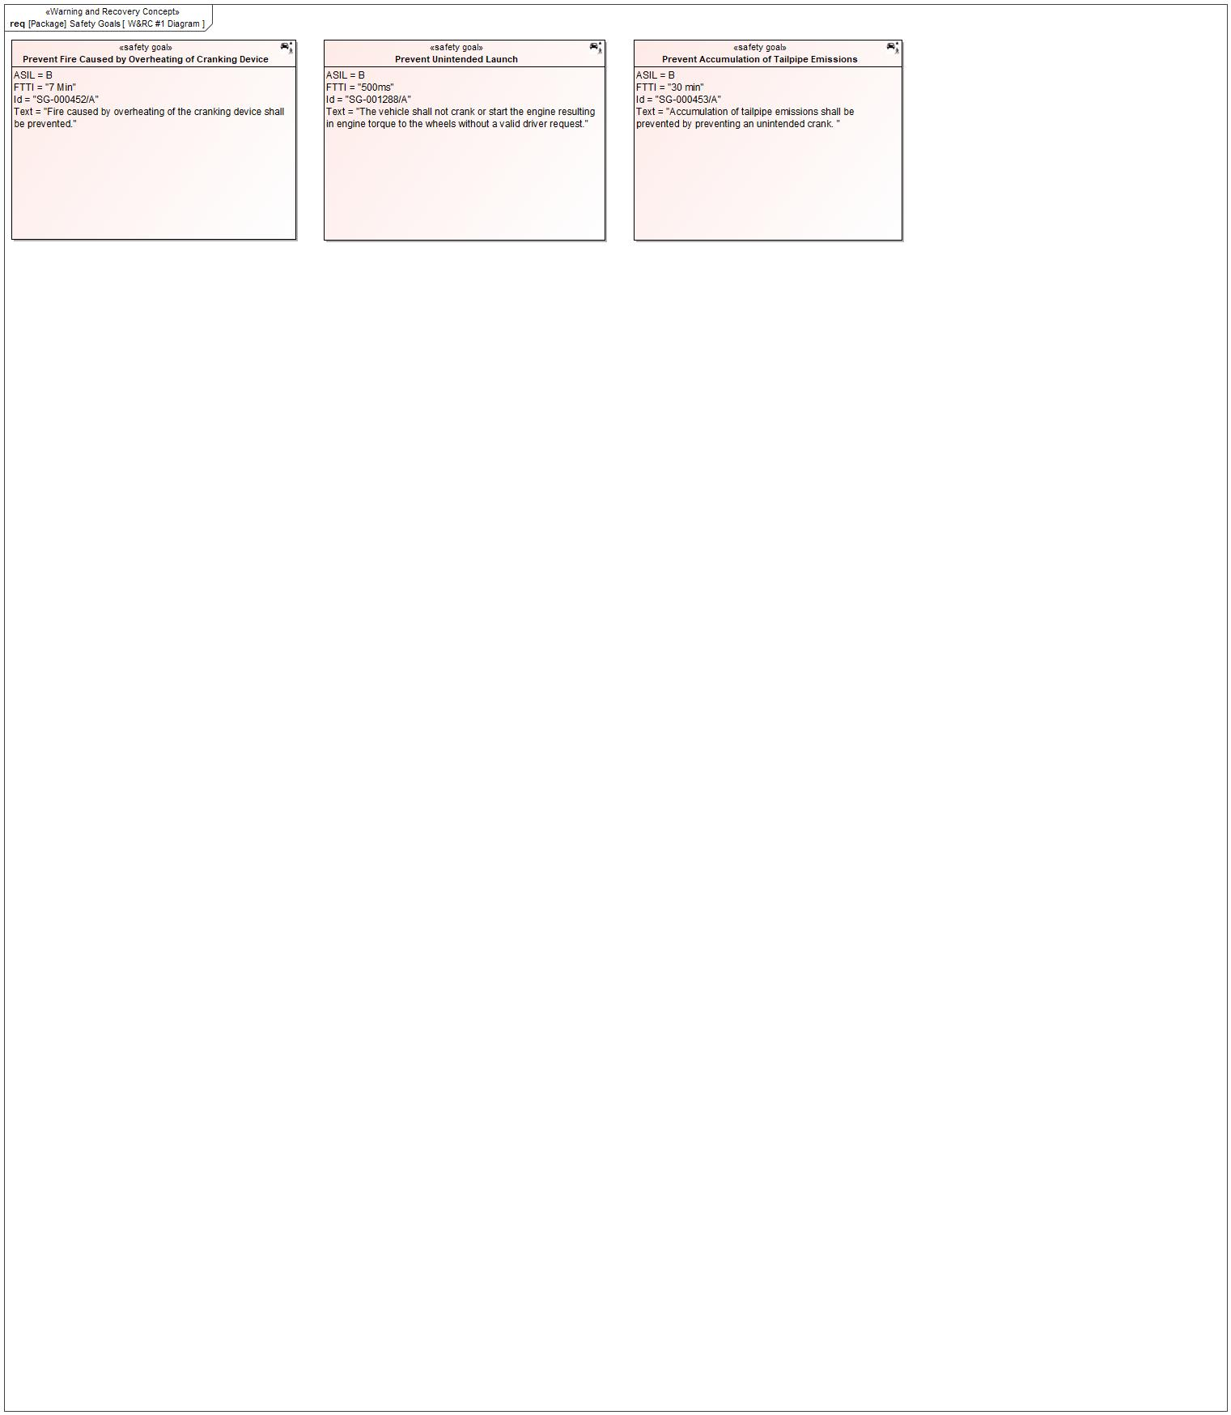

Figure 7: W&RC #1 Diagram – Prevent Fire Caused by Overheating of Cranking Device

### Safety Goal: SG-000453/A Prevent Accumulation of Tailpipe Emissions

**Name:** Prevent Accumulation of Tailpipe Emissions

**Purpose:**

**Text:** Accumulation of tailpipe emissions shall be prevented by preventing an unintended crank.

**ASIL:** B

#### Safety Goal Concept

No Safety Goal Concept diagram specified.

*Note: The authoritative source for the Safety Goals is document “FFSD 02 Hazard Analysis* *and Risk Assessment”. The documentation of Safety Goals in this chapter (In the Argumentation for Safety Goal achievement) is for information purposes only.*

*The authoritative source for the Functional Safety Requirements is section 2.1.x.3: of this document. The documentation of Functional Safety Requirements in the following chapter (complete or summarised) is for information purposes only.*

#### Warning and Recovery Concept

Please refer to the diagram W&RC #1 Diagram – Prevent Accumulation of Tailpipe Emissions.

### Safety Goal: SG-001288/A Prevent Unintended Launch

**Name:** Prevent Unintended Launch

**Purpose:**

**Text:** The vehicle shall not crank or start the engine resulting in engine torque to the wheels without a valid driver request.

**ASIL:** B

#### Safety Goal Concept

No Safety Goal Concept diagram specified.

*Note: The authoritative source for the Safety Goals is document “FFSD 02 Hazard Analysis* *and Risk Assessment”. The documentation of Safety Goals in this chapter (In the Argumentation for Safety Goal achievement) is for information purposes only.*

*The authoritative source for the Functional Safety Requirements is section 2.1.x.3: of this document. The documentation of Functional Safety Requirements in the following chapter (complete or summarised) is for information purposes only.*

#### Warning and Recovery Concept

Please refer to the diagram W&RC #1 Diagram – Prevent Unintended Launch.

### Derivation of Functional Safety Requirements on Assumptions

No Functional Safety Requirements tracing to Assumptions specified.

### ASIL Decomposition of Functional Safety Requirements

No Functional Safety Requirements with ASIL Decompositions specified.

# CyberSecurity

## Security Goals

|  |  |  |
| --- | --- | --- |
| ID | Goal | |
|  | **Goal Name** |  |
| **Description** |  |
| **CAL** |  |
| **Related CSR IDs** |  |
|  | **Goal Name** |  |
| **Description** |  |
| **CAL** |  |
| **Related CSR IDs** |  |
|  | **Goal Name** |  |
| **Description** |  |
| **CAL** |  |
| **Related CSR IDs** |  |

Table 18: Cybersecurity Goals

## Cybersecurity Requirements

# Architecture

## Functional Decomposition

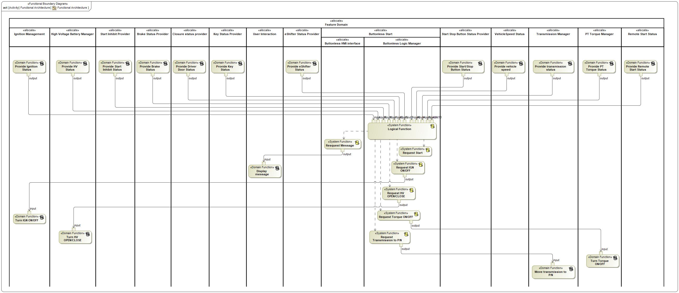

Figure 8: Functional Architecture

### Functions

| **Function Name** | Description | Comments |
| --- | --- | --- |
| *(activity)* Display message | *(activity)* HMI / IPC message is displayed. |  |
| *(activity)* Request Torque ON/OFF | *(activity)* Propulsive torque is enabled or disabled. |  |
| *(activity)* Request HV OPEN/CLOSE | *(activity)* Request HV contactors to move to OPEN or CLOSE |  |
| *(activity)* Provide Brake Status | *(activity)* Check if brake was pressed. |  |
| *(activity)* Provide Driver Door Status | *(activity)* Check driver´s door status (open, closed, moved to open, moved to closed). |  |
| *(activity)* Logical Function | *(activity)* Logical management of internal functions |  |
| *(activity)* Move transmission to P/N | *(activity)* Move gear position to Park/Neutral. |  |
| *(activity)* Provide PT Torque Status | *(activity)* Check torque status (enabled = motive mode ON; disabled = non motive mode). |  |
| *(activity)* Request Start | *(activity)* Routine to request vehicle start, moving from PwPckOff_TqNotAvailable to PwPckOn_TqAvailable |  |
| *(activity)* Request IGN ON/OFF | *(activity)* Request ISPR ON (Ignition Status = RUN) or OFF (Ignition Status OFF). |  |
| *(activity)* Resquest Message | *(activity)* HMI / IPC message is requested. |  |
| *(activity)* Provide Remote Start Status | *(activity)* Check if Remote Start Mode (Ignition Status = OFF AND PwPckOn_TqNotAvailable, HV Closed) is active or not. |  |
| *(activity)* Provide vehicle speed | *(activity)* Check vehicle speed. |  |
| *(activity)* Provide Start/Stop Button Status | *(activity)* Check Start Stop button status (pressed or released). |  |
| *(activity)* Turn Torque ON/OFF | *(activity)* Enable or disable propulsive torque. |  |
| *(activity)* Provide Key Status | *(activity)* Check if key is detected and valid. |  |
| *(activity)* Provide Ignition Status | *(activity)* Check Ignition status (ON=RUN or OFF). |  |
| *(activity)* Provide HV Status | *(activity)* Check HV Contactors status (OPEN or CLOSED) |  |
| *(activity)* Provide Start Inhibit Status | *(activity)* Check if any vehicle startup inhibitor is present (OTA, Impact Event, PATS). |  |
| *(activity)* Request Transmission to P/N | *(activity)* Move gear position to Park or Neutral. |  |
| *(activity)* Provide transmission status | *(activity)* Check transmission gear position (Park, Neutral, Drive, Reverse, Low). |  |
| *(activity)* Turn HV OPEN/CLOSE | *(activity)* Request HV Contactors to move to OPEN or CLOSED. |  |
| *(activity)* Provide eShifter Status | *(activity)* Check gear shift position. |  |
| *(activity)* Turn IGN ON/OFF | *(activity)* Request Ignition Status = ON (RUN) or OFF. |  |

Table 16: List of Functions

## Logical Architecture

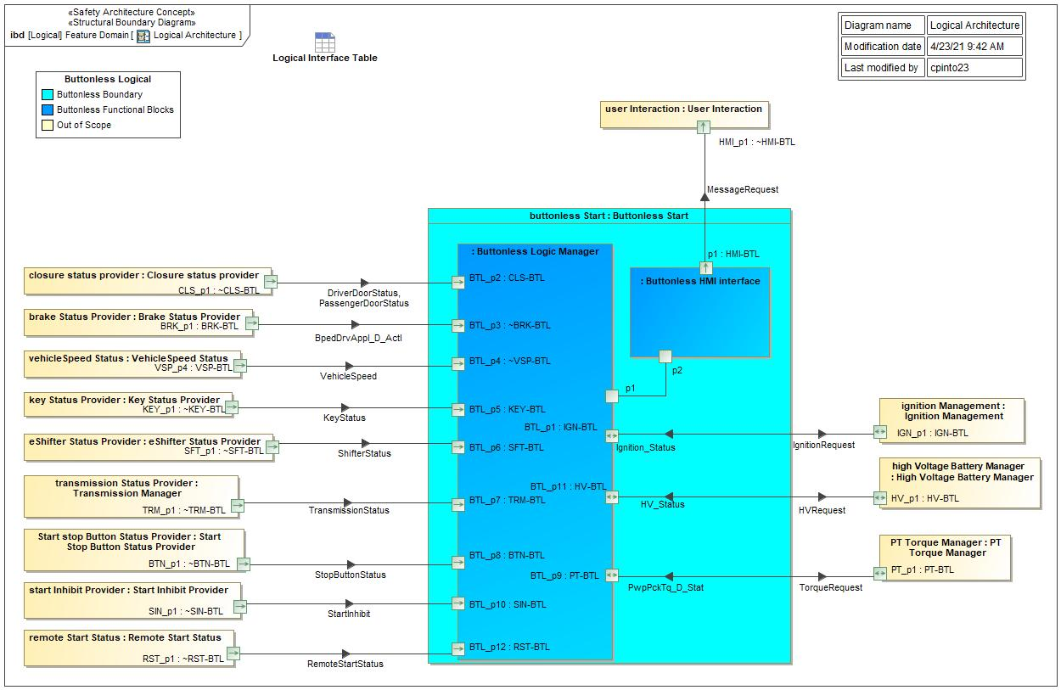

Figure 9: Logical Architecture

### Logical Elements

|  |  |  |  |
| --- | --- | --- | --- |
| **Element Name** | **Description** | **Allocated Functions** | **Comments** |
| Brake Status Provider | Check brake status if pressed or released. | * Provide Brake Status |  |
| Buttonless HMI interface | Center Stack or IPC | * Resquest Message |  |
| Buttonless Logic Manager | Buttonless logic implementation | * Logical Function * Request HV OPEN/CLOSE * Request IGN ON/OFF * Request Start * Request Torque ON/OFF * Request Transmission to P/N |  |
| Buttonless Start | Buttonless feature across modules | * Logical Function * Request HV OPEN/CLOSE * Request IGN ON/OFF * Request Start * Request Torque ON/OFF * Request Transmission to P/N * Resquest Message |  |
| Closure status provider | Check driver´s door status (open, closed, moved to open, moved to closed). | * Provide Driver Door Status |  |
| eShifter Status Provider | Check if gear button was pressed. | * Provide eShifter Status |  |
| High Voltage Battery Manager | Check status or request HV contactors OPEN/CLOSED. Check HV state of charge. | * Provide HV Status * Turn HV OPEN/CLOSE |  |
| Ignition Management | Check and request to change Ignition Status (ON = RUN, OFF, move to ON, move to OFF) | * Provide Ignition Status * Turn IGN ON/OFF |  |
| Key Status Provider | Check if key is detected and valid. | * Provide Key Status |  |
| PT Torque Manager | Enable or disable torque availability. | * Provide PT Torque Status * Turn Torque ON/OFF |  |
| Remote Start Status | Check if Remote Start Mode (Ignition Status = OFF AND PwPckOn_TqNotAvailable, HV Closed) is active or not. | * Provide Remote Start Status |  |
| Start Inhibit Provider | Check if any vehicle startup inhibitor is present (OTA, Impact Event, PATS). | * Provide Start Inhibit Status |  |
| Start Stop Button Status Provider | Check if Start Stop Button was pressed. | * Provide Start/Stop Button Status |  |
| Transmission Manager | Request gear position move to Park. Check transmission gear position. | * Move transmission to P/N * Provide transmission status |  |
| User Interaction | HMI / IPC message to be displayed. | * Display message |  |
| VehicleSpeed Status | Check vehicle speed. | * Provide vehicle speed |  |

Table 19: Logical Elements

### Logical Interfaces

|  |  |  |  |
| --- | --- | --- | --- |
| **Interface** | **Direction** | **Description** | **Value Range** |
| BpedDrvAppl_D_Actl | BRK_p1 (Brake Status Provider) To BTL_p3 (Buttonless Logic Manager) | Check if brake was pressed. |  |
| DriverDoorStatus | CLS_p1 (Closure status provider) To BTL_p2 (Buttonless Logic Manager) | Check driver´s door status (if open, closed, moved to open or moved to closed). |  |
| IgnitionRequest | BTL_p1 (Buttonless Logic Manager) To IGN_p1 (Ignition Management) | Request Ignition Status to move to ON (RUN) or OFF. |  |
| Ignition_Status | IGN_p1 (Ignition Management) To BTL_p1 (Buttonless Logic Manager) | Check Ignition Status (ON = RUN, OFF, moved to ON, moved to OFF). |  |
| KeyStatus | KEY_p1 (Key Status Provider) To BTL_p5 (Buttonless Logic Manager) | Check if key is detected inside the vehicle and valid. |  |
| MessageRequest | p1 (Buttonless HMI interface) To HMI_p1 (User Interaction) | Request message to be displayed to the user. |  |
| PassengerDoorStatus | CLS_p1 (Closure status provider) To BTL_p2 (Buttonless Logic Manager) | Check passenger door status (if open, closed, moved to open or moved to closed). |  |
| ShifterStatus | SFT_p1 (eShifter Status Provider) To BTL_p6 (Buttonless Logic Manager) | Check shifter position (Park, Neutral, Drive, Reverse or Low). |  |
| TransmissionStatus | TRM_p1 (Transmission Manager) To BTL_p7 (Buttonless Logic Manager) | Check transmission gear position (Park, Neutral, Drive, Reverse or Low). |  |
| VehicleSpeed | VSP_p4 (VehicleSpeed Status) To BTL_p4 (Buttonless Logic Manager) | Check vehicle speed status. |  |

Table 18: Feature Interactions

# Traceability Matrix

# Open Concerns

| ID | Concern Description | e-Tracker / Reference | Responsible | Status | Solution |
| --- | --- | --- | --- | --- | --- |
| 1 |  |  |  |  |  |

Table 20: Open Concerns *(Not supported by MagicDraw report generation)*

# Revision History

No Revision History found.

## Template Revisions

|  |  |  |  |  |
| --- | --- | --- | --- | --- |
| Version | Rev. | Date | Description | Responsible |
| 0 | 6 | 2015-05-26 | * Chapter “Feature Overview” and made a 2nd level heading. * Chapter “Feature Modeling” divided into 3 subchapter (“Scenarios”, “Use Cases”, “State Machines”) for different modeling methods | Jbaden1 |
| 0 | 7 | 2015-05-27 | * Table of Content updated * Template Revision History chapter added | Jbaden1 |
| 0 | 8 | 2015-07-02 | * Section “Unsettled Issues” added | Alevin7 |
| 0 | 9 | 2015-08-04 | * Section “Feature Variants” added * Section “Feature Boundary Diagram” renamed to “Feature Context Diagram” * Document Properties adapted to match needs of VBA macros | Jbaden1, Awegman1 |
| 1 | 0 | 2015-09-11 | * Section “Feature Variants” reworked * Feature Goals removed. Only “Safety Goals“ chapter remains. * Heading 2 formatting issues corrected. * Requirements / Use Cases Listing removed from traceability chapter. * Formatting of attribute table in Notation chapter corrected * Open Topics / Known Issues chapter moved to the end | Jbaden1 |
| 1 | 1 | 2015-11-16 | * Table-Styles removed (for smooth VSEM import) * Some clean-up of sections “Purpose” and “Audience” | Awegman1, jbaden1 |
| 1 | 2 | 2016-02-26 | * Minor corrections based on lessons learned from CC and PCL pilot (e.g. section market/regions) and discussion with Functional Safety Team (purpose of feature) * Footer corrected * Boundary diagram interface chapter renamed to influences. | Jbaden1 |
| 1 | 3 | 2016-02-26 | * Minor corrections after review with Whitney Keith from Functional Safety team | Jbaden1 |
| 1 | 4 | 2016-03-10 | * Some cleanup of meta-data in Word Properties | Jbaden1 |
| 1 | 5 | 2016-03-10 | * Footer formatting corrected (Issue 19) * Results from review with Functional Safety Team incorporated (Issue 20). | jbaden1 |
| 1 | 6 | 2016-04-18 | * Scenario Template added | Jbaden1 |
| 1 | 7 | 2016-04-18 | * Chapter “Operation Modes and States” moved before “Use Case” section. | Jbaden1 |
| 1 | 8 | 2016-04-18 | * Broken Wiki links repaired. | Jbaden1 |
| 2 | 0 | 2016-05-19 | * Adapted to Specification_Macros.dotm V2.0 * Requirements Templates chapter (ch. 1.7.1) no longer has an attribute table, but refers directly to the Wiki.. | Jbaden1 |
| 2 | 1 | 2016-06-10 | * Table for Context Diagram modified (lists external entities and Influence Description only) | Jbaden1 |
| 2 | 2 | 2016-07-08 | * Template version added to footer * Several hints added to the various sections * Findings from Functional Safety Team incorporated. * RE_SafetyRequirement style added | Jbaden1 |
| 2 | 3 | 2016-09-21 | * Update from Functional Safety Team incorporated (“Lessons Learned”, “System Behaviors for HARA”) | Jbaden1 |
| 2 | 4 | 2016-11-15 | * Update from Functional Safety Team incorporated (“Lessons Learned”, “System Behaviors for HARA”) * Explanatory notes made more formal | Jbaden1 |
| 3 |  |  | Skipped to synchronize with Specification_Macros.dotm |  |
| 4 |  |
| 5 | 0 | 2017-01-13 | * Meta data updated for specification macros, version 3.1 * SW Unit chapter removed for the time being * Green boxes added for user hints | Jbaden1 |
| 5 | 1 | 2017-01-18 | * Minor editorial changes | Jbaden1 |
| 6 | 0 | 2017-02-03 | * CR48: Chapter 6 renamed from “Safety” to “Functional Safety”. New sub-chapter “Safety” introduced in Non-Functional Requirements section | Jbaden1 |
| 6 | 0 | 2017-04-28 | * CR7: “RequirementsTraceability” chapter removed | Jbaden1 |
| 6 | 0 | 2017-11-15 | * CR32/53: New Cover Sheet + Disclaimer replaces FAP-150 like ones. * CR75: Some rewording -> Terminology to Glossary, Notation -> Document Conventions * CR49: Rename “Assumptions & Constraints” to “Assumptions” * CR74: Safety Assumptions added to chapter 6. * CR58: Add function allocation column to Logical Architecture chapter | Jbaden1 |
| 6 | 0 | 2018-01-31 | * CR63: Updated links to Functional Safety Sharepoint | Jbaden1 |
| 6 | 0 | 2018-07-24 | * CR69: Add FSR to FeatureDoc * CR64: Add new section "Design Requirements" to Function Spec and Feature Spec | Jbaden1 |
| 6 | 0 | 2018-08-06 | * CR53: some corrections for metada and formatting | Jbaden1 |
| 6 | 0 | 2018-09-28 | * Broken links to RE Wiki repaired | Jbaden1 |
| 6 | 0 | 2018-10-31 | * Cover sheet and footer more GIS like. Functional Safety team feedback incorporated:   + New subsections “Functional Safety Requirements, (Decomposed) FSRs and Parameters / Values   + Removal of “Logical Architecture” | Jbaden1 |
| 6 | 0 | 2018-12-12 | * FSR template removed, now as a macro in the Specification_Macros.dotm | Jbaden1 |
| 6 | 0a | 2019-05-23 | * Re-introduce “Logical Architecture” (for Functional Safety) | Jbaden1 |
| 6 | 0b | 2019-06-26 | * Chapter “Logical Elements” in “Logical Architecture” section added (FuSa CR 15136240) | Jbaden1 |
| 6 | 0c | 2019-03-22 | * Chapter “Decomposed FSRs” renamed to “ASIL Decomposition of Functional Safety Requirements” and moved beneath Chapter “Functional Safety Requirements”. Explanatory text improved. | Jbaden1 |
| 6 | 0c | 2019-04-05 | * Some wording in ASIL decomposition table modified. Description of fields in that table improved. | Jbaden1 |
| 6 | 0c | 2019-06-24 | * “Input Requirements” section modified (table approach as for the other RE templates). * “References” and “Glossary” chapter moved to the “Introduction” chapter. | Jbaden1 |
| 6 | 0c | 2019-07-02 | * "Important" box added on cover sheet which points to the macros | Jbaden1 |
| 6 | 0c | 2019-07-02 | * Subsection “Error Handling” removed form chapter “Feature Requirements”->”Functional Requirements” (teams are free to create their own substructure of that section). Note tells author not to forget about error handling. * Hint for chapter “Feature Variants” improved reworded upon request from Functional Safety Team. | Jbaden1 |
| 6 | 0c | 2019-05-11 | * Copyright notice shortened and moved to cover sheet and added to footer (to be compliant [with Ford copyright guidelines](http://www.fgti.ford.com/client/NewFGTI/CopyrightNotice.html)) * Term “Disclaimer” no longer used for what is actually only a copyright notice | Jbaden1 |
| 6 | 0c | 2019-22-11 | * Chapter “Input Requirements/Documentst: minor modifications (examples added), Word comment removed” | Jbaden1 |
| 6 | 0c | 2019-12-05 | * Upstream Documents section added to “Input Requirements/Documents” table * Custom style table formatting removed * Hint on system behaviors modified as requested from FuSa team | Jbaden1 |
| 6 | 0c | 2019-12-09 | * Term “Upstream Documents” replaced by “Attribute Requirements” in “Input Requirements/Documents” table * ASIL Decomposition table replaced by a version, which get not corrupted during VSEM import. | Jbaden1 |
| 6 | 0c | 2019-12-10 | * In ch. “Functional Safety Requirements” Word reference Id by Word reference text replaced.. | Jbaden1 |
| 6 | 1a | 2020-02-12 | * New chapter “Cybersecurity” added. | Jbaden1 |
| 6 | 1a | 2020-03-03 | * All User Hints formatted using style “RE_UserHint” to enable automatic removal by a macro. | Jbaden1 |
| 6 | 1a | 2020-03-04 | * Chapter “Cloud Connectivity Data Analytics Requirements” added upon request by D. Crockett/J. Rawlings | Jbaden1 |
| 6 | 1a | 2020-03-09 | * Missing doc property “LatestSigMappingID” and “LatestAisInterfaceID” added * doc property “CopyrightDate” re-formatted to text and copyright date field in footer corrected * Version numbering re-initialized as 0.1 * Init value of version/revision date set to “yyyy/mm/dd” instead of “yyyy-mm-dd” to be in line with the “Edit Document Property” dialog * type of document property for latest IDs changed to number instead of text | Jbaden1 |
| 6 | 1b | 2020-03-17 | * Chapter “Functional Architecture” renamed to “Functional Decomposition” * New MBSE terminology introduced: “Feature Level”, “Function Level” and “Component Level” renamed to “Concept Level”, “Logical Level” and “Technology Level” | Jbaden1 |
| 6 | 1b | 2020-07-03 | * CR31: Chapter “Traceability Matrix” added. | Jbaden1 |
| 6 | 1b | 2020-23-09 | * CR28: Alignment to [*FFSG01.10 Feature Document Guideline*](https://azureford.sharepoint.com/sites/GlobalFunctionalSafety/Released%20Templates%20Guidelines%20and%20Examples/Guidelines/FFSG01.10_FeatureDocument_Guideline.pdf) for how to apply the Feature Doc template for Functional Safety. New section “Classification of Chapters” added. “Active Tilt Control” Example in section “Logical Architecture” updated based on input from HARA training. | Jbaden1 |
| 6 | 1b | 2020-25-11 | * Reference to process definition in Stages added to “How to Use” section on cover sheet. User hints removed from “Document Purpose” chapter. * RE-Wiki links mostly replaced by Stages links, links to Functional Safety Sharepoint updated | Jbaden1 |

# Appendix

## Definitions

| **Definition** | **Description** |
| --- | --- |
| BEV | Battery Electric Vehicle |
| HMI | Human machine interface used to notify an information stream to the driver. In general this is show at instrument panel cluster |
| HV | High Voltage |
| HV Closed | HV Battery Contactors have closed and the HV battery can provide support for 12v and HV loads |
| Initialization Time | Time to Boot |
| MHT | Modular Hybrid Transmission |
| PUPD | Power Up and Power Down |
| Start up Time | Time to Boot |
| T15 or KL15 | Ignition Position II – Run Position |
| TLA | Three Letter Acronym |
| User | Person who operates the engine starting control |
| Wake Up Time | Time to Boot |

Table 21: Definitions used in this document

## Abbreviations

| **Abbr.** | **Stands for** |
| --- | --- |
| ABS | Anti-Lock Braking System |
| ACC | Accessory |
| ARL | Attribute Requirements List |
| BCM | Body Control Module |
| BOO | Brake On/Off |
| BPS | Brake Pedal Switch |
| CAN | Controller Area Network |
| D | Drive |
| DCO | Drive Control Optimization |
| DTC | Diagnostic Trouble Code |
| eBB | Electric Brake Boost |
| ECM | Engine Control Module |
| ECU | Electronic Control Unit |
| ERAD | Electric Rear Axle Drive. |
| EVCM | Electric Vehicle Control Module |
| FD | Feature Document |
| FGEC | Ford Gasoline Engine Control |
| FMEM | Failure Mode Effect Management |
| HSD | High Side Driver |
| ID | Identifier |
| IPC | Instrument Panel Cluster |
| IS | Ignition Switch |
| ISP-R | Ignition Switch Position - Run |
| ISP-S | Ignition Switch Position - Start |
| LSD | Low Side Driver |
| N | Neutral |
| NFC | Near Field Communication |
| NVM | Non Volatile Memory |
| P | Park |
| P/N | Park/Neutral |
| PaaK | Phone as a Key |
| PAAT | Powered At All Time |
| PATS | Passive Anti-Theft System |
| PCM | Powertrain Control Module |
| PDCM | Primary Drive Control Module |
| PWM | Pulse Width Modulated |
| rpm | Revolutions per minute |
| s | second(s) |
| SDCM | Secondary Drive Control Module |
| SI | Start Inhibit |
| V | Volts |
| VFG | Vehicle Function Group |
| VSC | Vehicle System Controller |

Table 22: Abbreviations used in this document

Document ends here.